|  |  |
| --- | --- |
| econstor  *Make Your Publications Visible.* | A Service of  Leibniz-Informationszentrum zbw Leibniz Information Centre  Wirtschaft for Economics |

Helble, Matthias

**Working Paper**

More trade for better health? International trade and

tariffs on health products

WTO Staff Working Paper, No. ERSD-2012-17

**Provided in Cooperation with:**

World Trade Organization (WTO), Economic Research and Statistics Division, Geneva

*Suggested Citation:* Helble, Matthias (2012) : More trade for better health? International trade and tariffs on health products, WTO Staff Working Paper, No. ERSD-2012-17, World Trade

Organization (WTO), Geneva, http://dx.doi.org/10.30875/4bfd1f50-en

This Version is available at: http://hdl.handle.net/10419/80068

**Standard-Nutzungsbedingungen:**

Die Dokumente auf EconStor dürfen zu eigenen wissenschaftlichen Zwecken und zum Privatgebrauch gespeichert und kopiert werden.

|  |
| --- |
| www.econstor.eu |

Sie dürfen die Dokumente nicht für öffentliche oder kommerzielle Zwecke vervielfältigen, öffentlich ausstellen, öffentlich zugänglich machen, vertreiben oder anderweitig nutzen.

Sofern die Verfasser die Dokumente unter Open-Content-Lizenzen (insbesondere CC-Lizenzen) zur Verfügung gestellt haben sollten, gelten abweichend von diesen Nutzungsbedingungen die in der dort genannten Lizenz gewährten Nutzungsrechte.

**Terms of use:**

*Documents in EconStor may be saved and copied for your personal and scholarly purposes.*

*You are not to copy documents for public or commercial purposes, to exhibit the documents publicly, to make them publicly available on the internet, or to distribute or otherwise use the documents in public.*

*If the documents have been made available under an Open Content Licence (especially Creative Commons Licences), you may exercise further usage rights as specified in the indicated licence.*

# Staff Working Paper ERSD-2012-17 Date: 18 October 2012

**World Trade Organization**

Economic Research and Statistics Division

**More Trade for Better Health?**

**International Trade and Tariffs on Health Products**

by

Matthias Helble

Universal Postal Union

*Manuscript date: October 2012*

________________________

**Disclaimer**: This is a working paper, and hence it represents research in progress. This paper represents the opinions of the author, and is the product of professional research. It is not meant to represent the position or opinions of the WTO or its Members, nor the official position of any staff members. Any errors are the fault of the author(s). Copies of working papers can be requested from the divisional secretariat by writing to: Economic Research and Statistics Division, World Trade Organization, Rue de Lausanne 154, CH 1211 Geneva 21, Switzerland. Please request papers by number and title.

More Trade for Better Health?

-

International Trade and Tariffs on Health Products

Matthias Helble[1]

**Abstract:**

The main objective of this paper is to analyse trade flows and tariff policies of health products. Compared to previous studies, we not only focus on medicines, but on a large set of products that enter the public health space and can be identified in the common trade classification. The first contribution is thus to construct three groups of health products based on the 2007 Harmonized System classification of international trade. Using these commodity groups, we analyse trade flows between 167 countries for the years 1996 to 2009. We find that trade in health products has developed very dynamically, with trade in dosified medicine displaying the strongest growth with an annual growth rate of almost 12 per cent. The results further indicate that the market of health products is dominated by a small number of developed countries. Looking at tariffs on health products for developed and developing countries as well as LDCs and transition economies we find that the overall level of tariffs is low, but far from being zero, especially in the last three country groups. Finally, studying the tariffs on health products in preferential trade agreements between developing countries, the results show that the tariff level is low, but in some individual cases still substantive.

***Keywords***: Public health, tariffs, trade, pharmaceuticals, medical devices, medical technology

***JEL Classifications***: F14, I11, O24

## **I. INTRODUCTION**

Health expenditures around the world have been growing strongly both in developed and in developing countries over the past decades. One key ingredient of every health system are physical goods that are directly used for diagnosis and treatment of patients or that are vital for other elements of the health system, such as laboratory equipment to conduct medical research. The other main ingredients are the delivery of health services and services related to public health (such as health insurance services, financial services, etc.). In an increasingly interconnected world, an ever larger share of these products and services is traded internationally. The objective of this paper is to analyse the development in international trade of health products and of the corresponding trade policies over the past fifteen years (1995-2009). Due to the paucity of international services' trade data, we only look at international trade in health products and not in health services.

Despite the growing importance of public and private expenditures related to health, there is not yet an agreed international definition of the "universe" of health products. This paper constitutes the first attempt to construct such a "universe" using the product classification of the Harmonized System (HS) as a basis. The HS is a classification that was developed to clearly identify products that enter a country at the border and to be able to accord the respective treatment. Having been developed from a trade perspective, it does not offer the refinement which, from a public health perspective, would be desirable. However, we believe that it offers enough detail to assemble a list of health products which covers a substantial share of all health products that enter the public health sphere and thus offers interesting opportunities for analysis.

In trying to build up a comprehensive universe of health products, our study contrasts with previous studies which have focused only on a subset of health products. For example, Krasovec & Connor (1998) looked at tax exemptions for three product groups, namely vaccines, oral rehydration salts, and contraceptives. Olcay & Laing (2005) analyse tariffs on pharmaceutical products.

Using this newly defined universe of health products, the paper analyses in detail international trade flows and trade policies applied to these products. It thus provides an important update and extension of previous studies, such as Olcay & Laing (2005). Foreshadowing the results, we find that international trade in health products, and especially trade in dosified medicines, has developed in a very dynamic manner over the past fifteen years. The market of health products, measured by exportations and importations, is heavily dominated by developed countries, while developing countries are gaining ground only slowly. Finally, we observe that the tariffs have come down substantially in all country groups: Developed, developing, transition countries as well as LDCs. However, even at a relatively low level, imposing tariffs still raises domestic prices for health products, especially for products with long supply chains.

The study is structured as follows: We first present the methodology used to establish the group of health products, followed by a short description of the data sources. In the section III the main results are presented and discussed. Finally, we summarize the main conclusions and suggest areas for future research.

**II. METHODOLOGY AND DATA**

## A. METHODOLOGY

(a) The Harmonized System Classification of international trade flows

Countries typically keep detailed records of goods that enter their domestic markets. In order to make national trade data comparable and in order to facilitate the exchange of goods across borders, the World Customs Organization has developed a classification for international trade in goods, the socalled Harmonized System (HS) which is now being widely used across the world. The HS classification dissects all trade flows into clearly distinguishable groups and breaks them down into 97 chapters and almost 6000 subheadings. It thereby follows a certain economic logic, mainly from crude products to more complex products and by sector of economic activity.

In this study, we are interested in all internationally traded goods that can contribute in one way or another to public health. Analysing in detail the HS classification (2007), we are able to identify 207 subheadings containing products which can be directly linked to a health purpose. In order to allow for further analysis, we regroup all 207 products into three groups (A, B, C) and five subgroups (A1, A2, A3, C1 and C2), namely:

1. A1: Dosified Medicines
2. A2: Bulk Medicines
3. A3: Inputs specific to the pharmaceutical industry
4. B: Chemical inputs of general purpose
5. C1: Hospital and laboratory inputs
6. C2: Medical technology equipment

Figure 1 presents the all groups and subgroups in a schematic way. Group A covers all products and specific inputs into the pharmaceutical industry. Subgroups A1, A2 and A3 thus contain products that are either finished medicines (A1 and A2) or specific inputs into the pharmaceutical industry (A3). Goods in groups B and C are produced by other industries. In the following we will explain in detail the composition of each of the six groups.

### Figure 1: Product Groups related to Public Health

Public Health

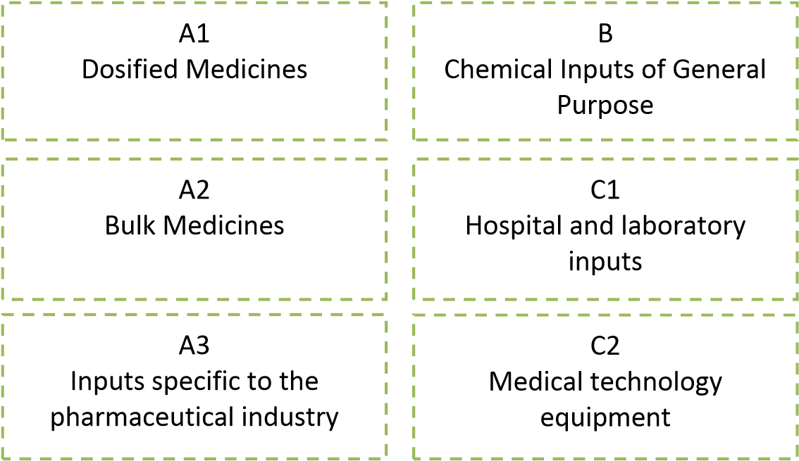

PHARMACEUTICAL INDUSTRY OTHER INDUSTRIES

### (i) Group A

The most obvious products to include from the HS classification are medicines (A1 and A2). Dosified medicines (A1) are covered under the HS heading 3004 and bulk medicines (A2) under HS heading 3003. Subgroup A1 comprises all subheadings (six-digit HS codes) of HS Code 3004 plus vaccines for human medicine (HS 300220), while subgroup A2 includes all subheadings of HS Code 3003:

A1: Dosified medicines:

* 300220 Vaccines for human medicine
* 300410 Medicaments Containing penicillins or derivatives thereof, with a

penicillanic acid structure, or streptomycins or their derivatives (Put up in Packings)

* 300420 Medicaments Containing Other Antibiotics (Put up in Packings for Retail

Sale)

* 300431 Medicaments Containing Insulin (Put up in Packings for Retail Sale)
* 300432 Medicaments Containing corticosteroid hormones, their derivatives or structural analogues (Put up in Packings)
* 300439 Medicaments Containing Other Hormones (Put up in Packings for Retail Sale)
* 300440 Medicaments Containing Alkaloids or Derivatives Thereof (Put up in Packings)
* 300450 Medicaments Containing Vitamins or Other Products of Heading 29.36 (Put up in Packings)
* 300490 Other Medicaments (Put up in Packings for Retail Sale)

A2: Bulk medicines:

* 300310 Medicaments Containing penicillins or derivatives thereof, with a penicillanic acid structure, or streptomycins or their derivatives
* 300320 Medicaments Containing Other Antibiotics
* 300331 Medicaments Containing Insulin
* 300339 Medicaments Containing Other Hormones
* 300340 Medicaments Containing Alkaloids or Derivatives Thereof
* 300390 Other Medicaments

From a public health perspective these HS subheadings might appear insufficient as they offer little details, making it difficult to detect the specific amount of certain medicines that are traded. For example, one might be interested to know which specific medicines, including the name and dosage, containing insulin were imported. The HS classification at the six digit level leaves these questions open. Several countries apply more specific goods classifications beyond the six-digit codes. However, as these codes are not yet harmonized at the international level, it is not possible to use them for comparative statistical analysis.

The production of drugs requires certain inputs. The HS classification specifies 57 subheadings which are used explicitly for the production of pharmaceuticals. These inputs, which we label A3 (Inputs specific to the pharmaceutical industry), can be found in the following HS headings: 2935, 2936, 2937, 2939, and 2941. A detailed list of the 57 subheadings can be found in the Appendix 1 of this paper.

### (ii) Group B

Obviously, not all inputs used in the production of pharmaceuticals are specific to that sector, but are also used in other industries. For example, under HS 292142 we find 'Aniline Derivatives', which are needed for the production of Paracetamol. At the same time, aniline derivates are used since the 19th century as important ingredients for dyestuffs. Most of these chemicals that are used in the pharmaceutical industry and beyond fall under the HS Chapter 29 "Organic Chemicals".

There is yet no agreed international definition which formally establishes a list of organic chemicals that could be considered relevant inputs into the production of pharmaceuticals. At the international level the "Pharmaceutical Tariff Elimination Agreement" (PTEA) gives some indication which products might be regarded to be pertinent in this context. The PTEA was concluded in 1994 during the WTO Uruguay Round and entered into force on 1st, January 1995. Under this agreement, which was signed by nine WTO Members, all parties have eliminated tariffs on all finished pharmaceutical products.[2] For active ingredients and intermediates zero tariffs do not automatically apply, but need to be added to the list of eligible products. The PTEA therefore contains at the end a detailed list of products that some or all signatories consider active ingredients and intermediates and thereby grant duty free market access. We estimate that this list gives some valuable indications of products that could be considered relevant inputs into the production of medicines. In our analysis we have therefore included all those subheadings that eight out of the nine signatories have added to the list of eligible products. In total, product group B is composed of 73 HS subheadings, mostly from chapter HS 29 (see Appendix 1).[3]

### (iii) Group C

The HS classification holds other goods beyond medicines that can be considered relevant inputs for public health. First, we have identified hospital and laboratory inputs (C1). Two examples of hospital inputs are HS subheading 300590: 'Wadding, gauze, bandages and the like', and HS subheading 901831: 'Syringes, with or without needles, used in medical, surgical, dental or veterinary sciences'. As the last example demonstrates some of these products might not only be used for human health purposes, but also for the treatment of animals. The question of multiple use becomes even more apparent for laboratory inputs. For example, HS Code 701710 contains 'Laboratory, hygienic or pharmaceutical glassware, whether or not graduated or calibrated, of fused quartz or other fused silica'. In order to limit the problem of multiple use, we have only included those product lines, where a direct link, such as "pharmaceutical", is included in the product description. Overall group C1 contains 28 HS subheadings (see Appendix 1).

Second, we have identified medical technology equipment (C2), which encompasses all those products which are used either for diagnosis, such as ultraviolet or infra-red ray apparatuses (HS 901820), or in treatment, such as ozone therapy apparatuses (HS 901920) or artificial joints for orthopaedic purposes (HS 902111). Overall, group C contains 61 HS subheadings (28 in C1 and in 33 C2).

### (iv) Caveats

One of the key challenges when working with the HS classification is that at the six-digit level one might capture products that are not used exclusively in the health sector, but also in other sectors. A very stark example of this problem is the case of malaria bed nets. Bed nets are officially imported under the tariff subheading HS 630493: "Not knitted or crocheted, of synthetic fibres; articles for interior furnishing, of synthetic fibres (excl. knitted or crocheted, blankets and travelling rugs, bed linen, table linen, toilet linen, kitchen linen, curtains, incl. drapes, interior blinds, curtain or bed valances, bedspreads, lampshades and articles of heading 9404)". For many countries, the largest part of the importations or exportations under HS 630493, both in terms of volume and value, are probably not malaria bed nets, but blankets, bed linen, etc.

Not only the trade flows recorder under HS 630493 are composed of different products, but also the custom duties for HS 630493 are an average of all tariff lines that a countries apply at a higher level of disaggregation to the different products within this specific HS code. As a consequence, the average custom duties for HS 630493 might appear substantive, even though malaria bed nets might enter the country duty free. The study of Simon, Larson, Zusman, & Rosen (2002)on the importance of lowering tariffs on insecticide treated bed nets suffer from this methodological challenge. The authors themselves state that "the ambiguous nature of the coding systems makes it difficult to determine accurate tariff rates for ITNs…" (Simon et al., 2002, p. 5). In order to avoid this kind of problems, we have attempted to include only those subheading for which we had evidence that the use is predominantly for public health purposes or that included goods of multiple use, health being one of them (such as laboratory equipment). Following this logic, we decided to exclude the tariff headings such as HS 630493 from our sample.

Overall, the drawbacks of working with the HS subheadings are mainly twofold. First, as the example of the bed nets illustrates, a particular HS subheading might cover in its majority non-health related products. In order to guarantee a certain level of accuracy in the trade flows that we measure and that are related to public health, we find ourselves obliged to ignore international trade in some goods that actually do enter the public health space.

Second, in case products have multiple uses, and only one being for public health, we include in our trade statistics products which do not enter in their entirety the public health domain. The commodity group B (Chemical inputs of general purpose) is a good example for this problem, as chemical inputs of general purpose are needed in very many sectors.

In summary, using the HS classification at the six-digit (subheading) level we are on the one hand unable to capture all trade flows that contribute to public health, and on the other hand, we overstate some trade flows, since we are unable to fully discriminate between trade flows related to public health and those that are unrelated. The trade and tariff statistics that are presented in the sections below should therefore be interpreted with caution.

Another caveat when interpreting the data in the subsequent sections concerns the units used to measure trade. International trade statisticts are typically recorded in national currencies and then converted into current US Dollars. It is common practice to compare trade flows across time without adjusting for US inflation, which we follow in this paper. According to the US Consumer Price Index data, the inflation in the United States was between 1.6 and 3.8 per cent annually between the years 1995 to 2008 and minus 0.4 in 2009.[4] The compounded inflation rate from 1995 to 2009 was 28.1 per cent, in other words, the value of trade flows in 2009 would need to be divided by 1.281 in order to compare them with the value of trade flows in 1995. In the following sections, we present yearly trade data and growth rates for the periods 1995 to 2009 without inflation adjustment. The yearly growth rates would have to be adjusted on average by around 1.7 per cent in order to obtain the inflationadjusted value.

**III. RESULTS**

## A. INTERNATIONAL TRADE IN HEALTH PRODUCTS FROM 1995 TO 2009

### **1. General Overview of Trade Data**

Let us first start with some general trade statistics. Graph 1 depicts the evolution of trade (measured in total imports) in all three commodity groups (A, B, and C) among 167 countries (see Appendix 2) from 1995 to 2009.[5] The first observation is that overall trade in health products grew substantially from 92 billion USD in 1995 to about 419 billion USD in 2009, which equals an annual growth rate of about 11.5 per cent. Compared to the average growth rate of overall world trade, which has been around 6 per cent per year (measured in current US Dollars),[6] international trade in health products thus developed particularly strongly. In 2009, trade in health products (commodity groups A, B plus C) represented 3.7 per cent of total international merchandise trade (not depicted in graph).

### Graph 1: Development of world trade of the three commodity groups A, B and C (1995-2009, Million USD) Development of international trade in health products by commodity groups A, B and C from 1995-2009 (in Million USD)

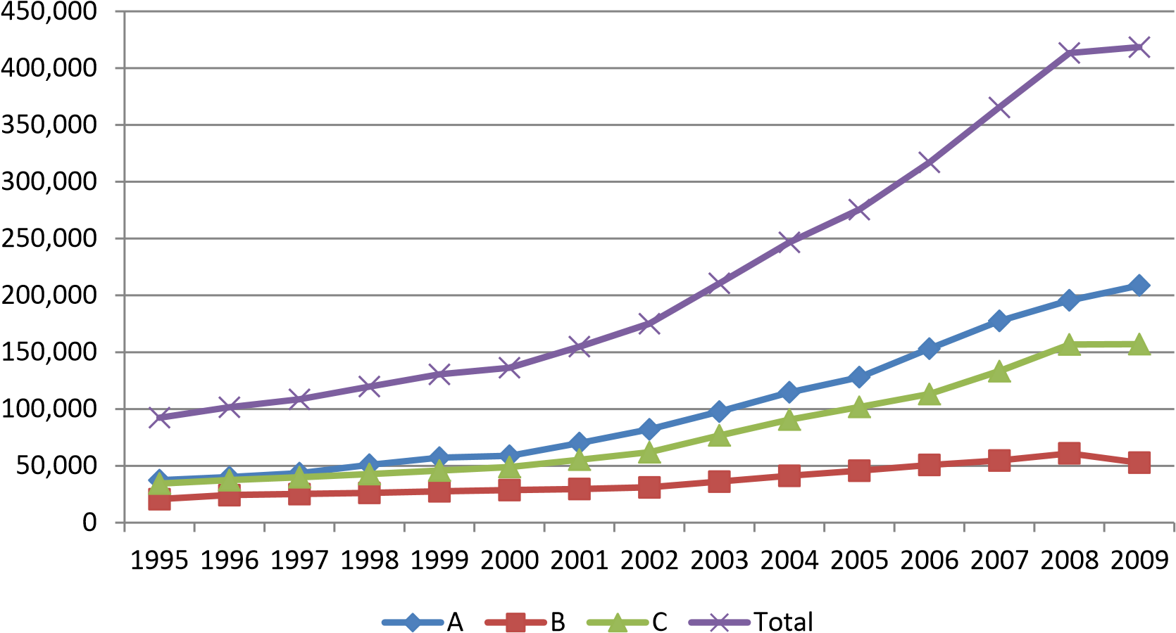

### Sources: COMTRADE, WTO Secretariat

Comparing the evolution of trade in the three main commodity groups (A, B and C), we notice that the commodity group A constituted the largest share (in value terms) over the entire period, and at the same time, this group exhibited the strongest growth performance. It rose from around 37 billion USD in 1995 to 208 billion USD in 2009, an almost sixfold increase. Growth of trade in chemical inputs of general purpose (B) was in line with overall growth in international trade and increased from about 20 billion to 60 billion USD within the time period. In contrast, trade in hospital and laboratory inputs as well as in medical technology equipment (C1 and C2) showed a very impressive growth rate, with global trade almost reaching 163 billion USD while having started at 34 billion USD fifteen years earlier. Overall, we observe that global trade in health products has developed in a very dynamic way over the past fifteen years and seems to play an increasingly important role for the supply of health goods.

It is also interesting to study individually the evolution of international trade in the subgroups A1, A2, C1 and C2 (Graph 2, measured in imports). The subgroup A1 (dosified medicines) showed the strongest growth performance, increasing from around 21 billion USD in 1995 to 186 billion USD in 2009. The other two subgroups of the pharmaceutical industry, namely A2 and A3, developed in a less dynamic, but still impressive, way. Global trade in A2 products (bulk medicines) almost quadrupled in 15 years, reaching 9.5 Billion USD in 2009. Global trade in A3 (specific inputs into the pharmaceutical industry) followed the increase of overall world trade and more than doubled within fifteen years. Global trade in hospital’s and laboratory inputs (C1) has also flourished, reaching 77 billion USD in 2009 while having started at 14 billion USD fifteen years earlier. Trade in medical technology equipment (C2) more than quadrupled (from 19 Billions USD in 1995 to 86 Billion USD in 2009) and thus clearly outperformed total global trade growth over this period. Comparing the five subgroups, dosified medicine (A1) and hospital and laboratory input (C1) have been experienced the strongest growth rates.

#### Graph 2: Development of overall trade of the five commodity subgroups A1, A2, C1 and C2 (19952009, in Million USD)

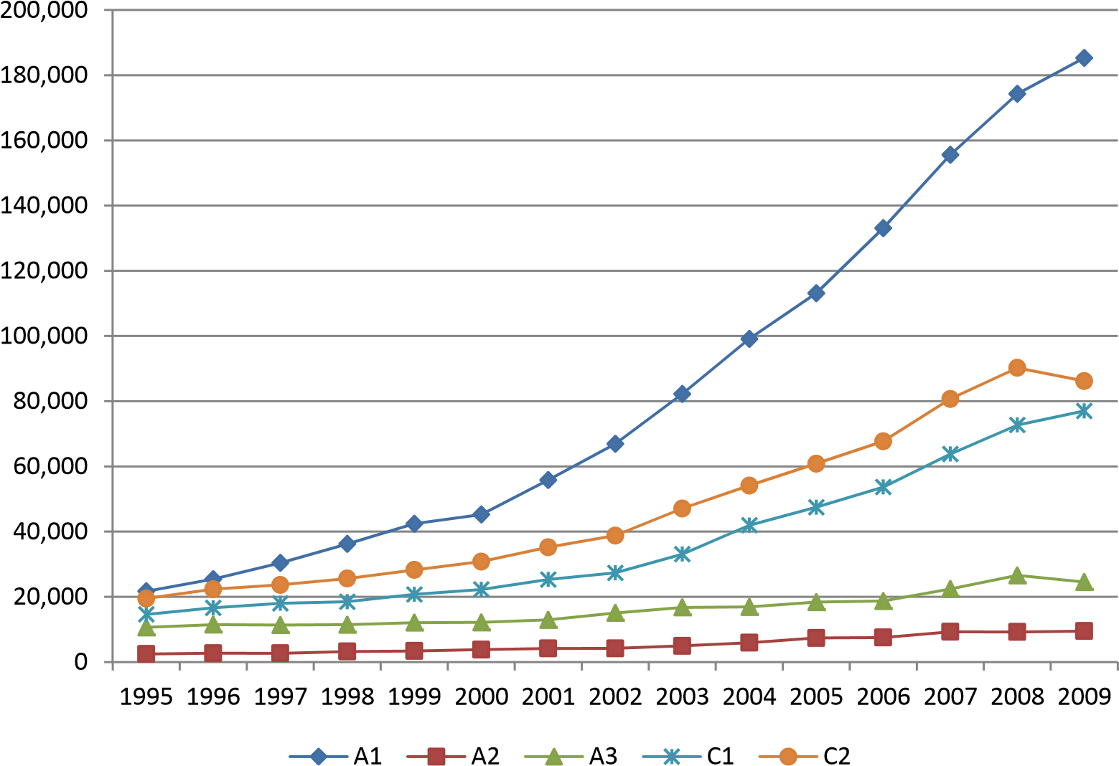

### Source: COMTRADE, WTO Secretariat

#### **2. Key Players in the International Trade of Health Products**

Almost all countries and economies are participating in the global trade of health products, either as exporters or as importers or both. Dividing all countries into four groups, namely developed and developing countries, LDCs and finally transition countries, allows us to analyse the country groups which have been particularly involved in international trade of health products. Graph 3 depicts the participation in international trade of health products, measured in imports, of the four country groups from 1995 to 2009.

Studying the evolution over the fifteen years, one observes that the participation among the two major groups, namely developed and developing countries, has not substantively changed. Developed countries accounted for around 70 per cent of all imports, developing countries for around 25 per cent. The rest of imports can be attributed to LDCs and to a growing extent to transition countries. The overall picture of a strong domination in imports by developed countries can be explained by several factors. First, developed countries are typically more integrated into the world economy and thus participate very actively in supply chains. Second, it might also reflect the fact that there exists a substantial gap in the per capita spending for health care (private and public) between the four country groups. Developed countries spend a substantially higher share of their public and private expenditures on health products compared to the other three groups. The trade data indicates that developed countries with around 1 billion inhabitants import more than double than the 5.7 billion inhabitants living in the other three country groups.

It is very interesting to observe that this imbalance identified in the trade data is reflected almost identically in data on global health expenditure for medicines. According to IMS (2011) in 2010 developed countries spent about 69 per cent of all global health expenditures for pharmaceutical. International trade data on health products thus seems to be an excellent indicator of difference in health spendings across different country groups.

#### Graph 3: Imports of health products by country group (1995-2009)

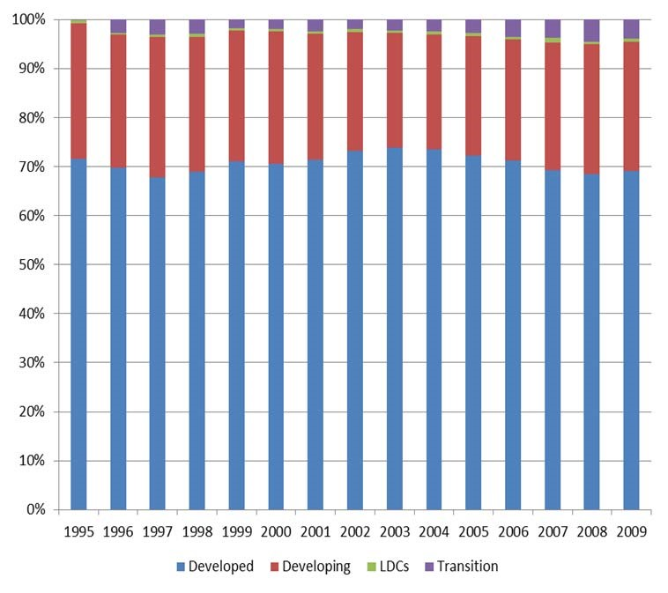

### Source: COMTRADE, WTO Secretariat

Let us now turn to the share between the four country groups for *exports* of health products (Graph 4). The export market is even more strongly dominated by developed countries than global imports. Until 2002, developed countries exported around 85 per cent of all health products, whereas developing countries accounted for around 15 per cent. Since 2003 the share of developing countries has been constantly increasing to more than 20 per cent in 2008 and 2009, reducing the developed countries' share to around 80 per cent. LDC and transition economies have not played any significant role in the worldwide exports of health products over the past fifteen years.

In order to explain the dominance of developed countries in the export of health products, one would need to analyse several economic variables which is beyond the scope of this paper. We therefore would limit ourselves to some rather general explanation. First of all, the production of the majority of the health products included in our sample requires some kind of technological sophistication, which is still predominantly found in developed countries. Second, the majority of the research and development efforts in the health sector are still undertaken in developed countries. Another reason is that markets for pharmaceutical products and medical devices are dominated by companies based in developed countries. However, the recent trend towards a stronger participation of developing countries in global exports of health goods seems to indicate that developing countries have become more and more successful in their R&D efforts and in the production of competitive health products.

#### Graph 4: Exports of health products by country group (1995-2009)

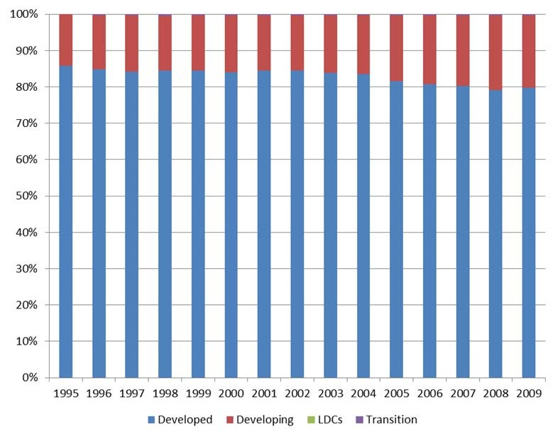

Source: COMTRADE, WTO Secretariat

It is worthwhile looking more in detail at specific countries that are active in the import and export of health products. Table 1 lists the top 20 exports and imports of health products as defined in our sample for the year 2009. Looking at the top importers, we observe that the EU and the US account for almost half of worldwide imports. Japan, Switzerland and Canada together hold a share of 15 per cent. Interestingly, Switzerland imports more health products than China and Brazil taken together.

Overall, the first top ten top importers account for over 77 per cent of global imports. Four out of the top ten importers are developing countries. All other countries that are ranked 21 and lower have a share of less than 2 per cent in the global import market.

Turning to the main exporters, the picture is even more skewed towards a handful of major exporting countries. The EU, the US and Switzerland cover 73 per cent of global exports of health products. Three developing countries, namely China, India and Mexico, are among the top ten exporters, however they only account together for around 9 per cent of global exports. Summing up the export shares of the top ten exporters totals 92 per cent of the global export market.

Some words of caution about the above analysis might be in order at this stage. First of all, we have considered the European Union as a single importer and exporter and thereby excluded all trade flows within the European Union. If we had taken intra-EU trade flows into account, the overall picture would have been more skewed towards developed countries. Second, trade data always suffer to some extent from the problem of transhipments. Health products might be imported in order to be reexported. Economies which are important redistribution hubs, such as Singapore or Hong Kong, might therefore register excessively high levels of imports and exports. It is not always possible to correct for these transhipments as not all countries report their re-exports or re-imports. For those countries in our sample that have reported re-export or re-imports we did not find a significant difference to regular import and export data.

#### Table 1: Top 20 importers and exporters (A+B+C) 2009

|  |  |  |  |  |  |  |  |
| --- | --- | --- | --- | --- | --- | --- | --- |
|  | **Top 20 importers** | | | | **Top 20 exporters** | |  |
| 1 | EU | 102602.5 | 24.33% 1 | EU | | 159378.4 | 38.08% |
| 2 | USA | 97841.2 | 23.20% 2 | USA | | 88153.2 | 21.06% |
| 3 | Japan | 26316.9 | 6.24% 3 | Switzerland | | 58897.5 | 14.07% |
| 4 | Switzerland | 24549.5 | 5.82% 4 | China | | 22244.0 | 5.31% |
| 5 | Canada | 17752.0 | 4.21% 5 | Japan | | 13262.3 | 3.17% |
| 6 | China | 14973.8 | 3.55% 6 | Singapore | | 11622.7 | 2.78% |
| 7 | Russian Fed | 12160.6 | 2.88% 7 | India | | 10039.1 | 2.40% |
| 8 | Australia | 11394.7 | 2.70% 8 | Canada | | 7938.3 | 1.90% |
| 9 | Brazil | 9293.9 | 2.20% 9 | Mexico | | 6548.1 | 1.56% |
| 10 | Mexico | 8368.5 | 1.98% 10 | Israel | | 6167.0 | 1.47% |
| 11 | Korea Rep. | 7507.2 | 1.78% 11 | Australia | | 4387.7 | 1.05% |
| 12 | Turkey | 6672.2 | 1.58% 12 | Panama | | 3683.5 | 0.88% |
| 13 | India | 5896.0 | 1.40% 13 | Hong Kong | | 3471.5 | 0.83% |
| 14 | Singapore | 4845.6 | 1.15% 14 | Korea Rep. | | 3156.2 | 0.75% |
| 15 | China Taipei | 4081.3 | 0.97% 15 | Brazil | | 2170.1 | 0.52% |
| 16 | Venezuela | 4022.1 | 0.95% 16 | China Taipei | | 1803.7 | 0.43% |
| 17 | Hong Kong | 3734.8 | 0.89% 17 | Norway | | 1453.6 | 0.35% |
| 18 | South Africa | 2919.6 | 0.69% 18 | Malaysia | | 1361.4 | 0.33% |
| 19 | Norway | 2901.5 | 0.69% 19 | Thailand | | 1273.1 | 0.30% |
| 20 | Argentina | 2828.6 | 0.67% 20 | Costa Rica | | 993.4 | 0.24% |
| 21 | Others | 51093.6 | 12.11% 21 | Others | | 10579.4 | 2.53% |

Source: COMTRADE, WTO Secretariat

Another way of analysing the importance of trade for the provision of health products is to look at the imports of dosified medicines per capita in the four country groups over time (Graph 5). As can be seen in Graph 5, imports per capita increased substantially in all four country groups. The strongest increase was experienced in transition economies which started at a very low level (0.20 USD) and reached 48.21 USD in 2009. Imports per capita in developed countries also showed a very strong growth performance and increased by around 16 per cent every year. In a similar manner, developing countries saw their imports per capita grow substantially every year, almost sextupling within fifteen years (from 1.63 USD in 1995 to 9.64 USD in 2009). In contrast, the increase of per capita in LDCs was rather modest, growing from 0.82 USD in 1995 to 2.42 USD in 2009. As only very few LDCs produce pharmaceuticals and therefore entirely rely on imports, this result gives some indication how the consumption of medicines has evolved in these countries from 1995 to 2009. We can observe that although an improvement has occurred, it has been rather modest compared to the other country groups. Looking only at data on imports per capita it is difficult to give an accurate explanation why LDCs are relatively falling behind. The trade patterns are probably a reflection of various elements, such as slow economic growth or limited resources available for health at the public and private level.

#### Graph 5: Per capita imports of dosified medicines (A1) by developed, transition, developing countries and LDCs from 1995-2009 (in current US Dollars)

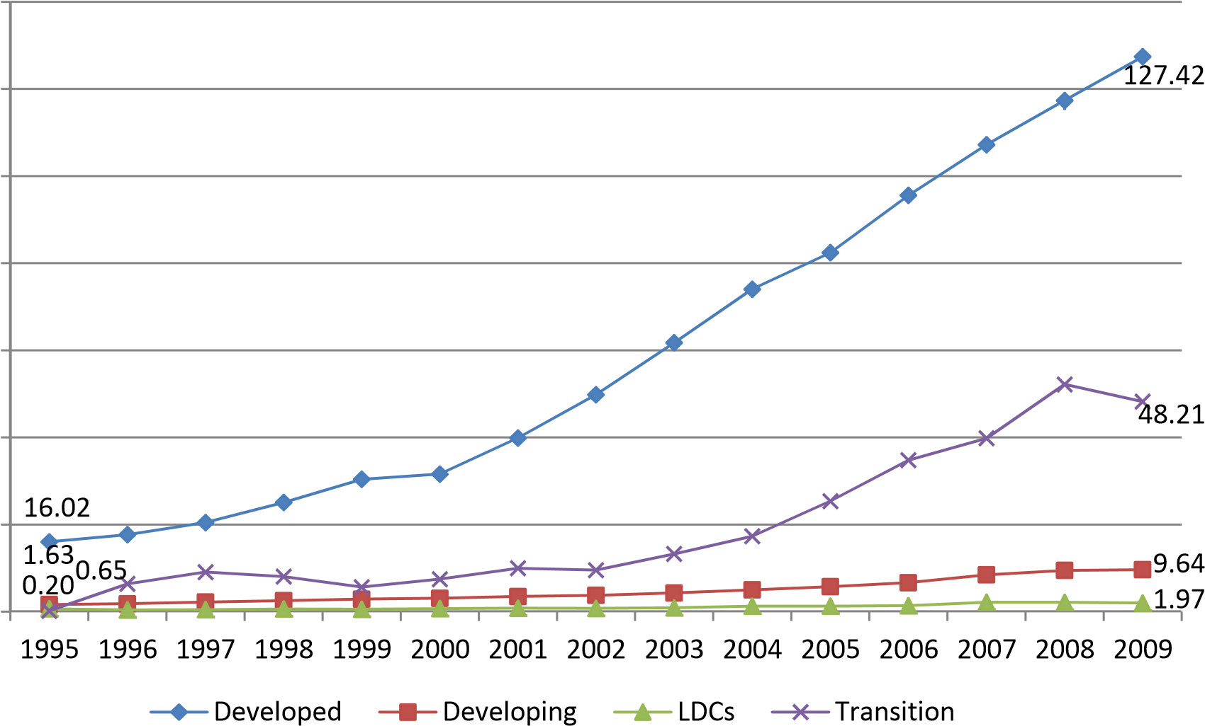140.00

120.00

100.00

80.00

60.00

40.00

20.00 0.00

Source: COMTRADE, WTO Secretariat

## B. TARIFF POLICY FOR HEALTH PRODUCTS FROM 1995 TO 2009

### **1. Multilateral Tariff Policy**

(a) Introduction

Trade policy can have a substantive impact of trade flows mainly by changing prices for consumers and producers and thereby altering demand and supply for imports and exports. In this section we study the tariffs for all health products defined above (A1, A2, B, C1 and C2).

Compared to international trade data, tariff data is not reported with the same frequency to the respective international bodies, such as the WTO. One reason being that customs duties are not adjusted every year, and therefore countries do often not see the need to notify tariffs annually. As a consequence, the tariff data that is available in WTO's Integrated Database for WTO Members and other countries is not fully complete which makes an analysis by year (as above for trade flows) difficult. We have therefore chosen four years, namely 1996, 2000, 2005 and 2009 and taken the data of that year or closest to that year as a proxy. Using this approach, we were able to construct small time series for all product groups and country groups.

An important conceptual distinction to be made when it comes to tariffs is the difference between bound and applied tariffs. All WTO Members have mutually committed themselves to guarantee a certain level of market access, which typically translates into a specific level of tariff rates (customs duty) for goods' trade. According to WTO rules, once a Member has made a commitment towards other Members not to increase a rate of customs duty beyond an agreed level, it cannot raise it without compensating the affected parties. In other words, once a WTO Member has bound its tariff at the WTO, it cannot easily break this commitment. Developed country Members have bound 99 per cent of their product lines and developing country Members 73 per cent. WTO Members are obviously allowed to charge customs duties lower than the bound rates. These tariff rates, called applied rates, can be subject to changes, but the bound rates serve as upper ceilings. In the following, we will first analyse the evolution of applied tariff rates and we then study the difference between applied and bound tariff rates.

The data presented below only includes tariff data from WTO Members and other countries for which information is available in the WTO Integrated Database. For some countries tariff data is not available for any of the four points in time, and therefore these countries are excluded from our sample (see Appendix 3 for list of countries included). The tariff data for each commodity group is trade weighted, meaning that tariffs levied on larger imports are given more weight compared to smaller imports.

(b) Applied Tariff Rates for Health Products

As we can see in Graph 6, applied tariffs for health products in developed countries are generally low and have been further reduced over the past fifteen years. Already since 1996, medicines and their inputs (A1, A2 and A3) enter most developed countries' markets duty free. Applied tariffs on medical technology equipment (C2) were low and have further come down and are, since 2000, at around 0.5 per cent. Tariffs on hospital and laboratory inputs (C1) are close to 1.5 per cent. The only product group for which tariffs might still significantly impact final prices are chemical products (B). Tariffs levied on these products have been reduced from less than 6 per cent in 1996 to around 3 per cent in 2009.

### Graph 6: Applied tariffs (trade weighted) by developed countries in six product groups

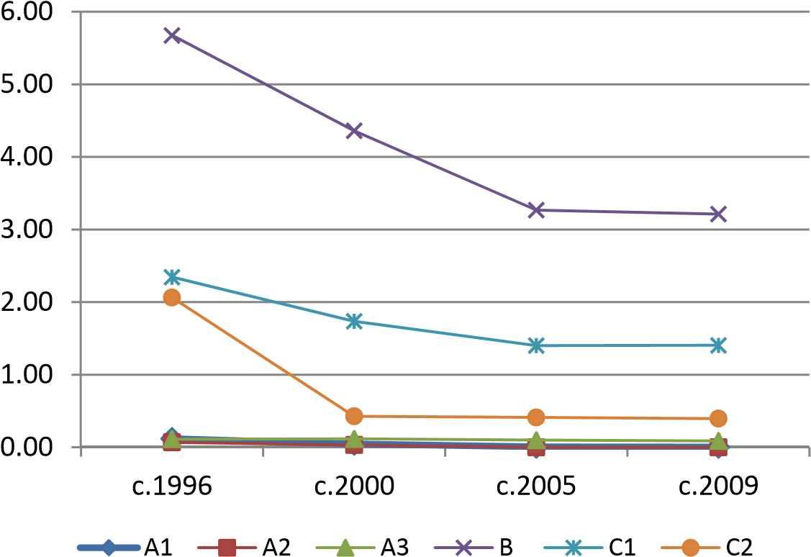

Source: COMTRADE, WTO Secretariat

Applied tariffs on health products in developing countries have also come down substantially over the period 1995 to 2009, as depicted in Graph 7. For example, in 1995, tariffs of around 7 per cent were levied on dosified medicine (A1), whereas today the average applied tariff is about 4.5 per cent. The tariffs on specific inputs into the pharmaceutical industry (A3) were reduced from about 7.5 per cent in 1996 to 3 per cent by 2009. Applied tariffs on hospital and laboratory inputs (C1) came down from about 8 per cent to 5.5 per cent. Overall, the applied tariffs on all five health product groups are now situated between approximately 3 and 5.5 per cent, compared to a range of around 4.5 to 8 per cent fifteen years earlier.

*Graph 7: Latest applied tariffs (trade weighted) by developing countries in six groups*

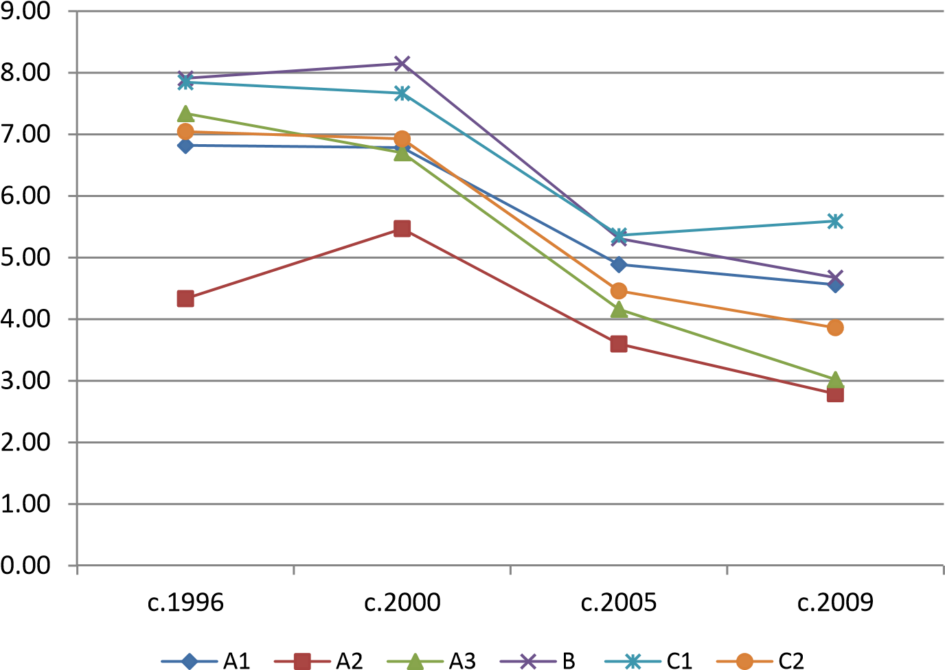

Source: COMTRADE, WTO Secretariat

For LDCs the picture is similar, as Graph 8 shows. Applied tariffs on dosified medicines (A1) have been reduced from over 3 per cent in 1996 to around 1 per cent in 2009. The tariffs for dosified medicines (A2) and for specific inputs into the pharmaceutical industry have been reduced more modestly from 4.9 to 4.2 per cent and from 5.7 to 5.2 per cent, respectively. Applied tariffs on product groups A3 and C2 remained stable at around 5.5 per cent. Tariffs on product groups B and C1 have been decreased by two and one percentage points respectively.

### Graph 8: Latest applied tariffs (trade weighted) by LDCs in six groups

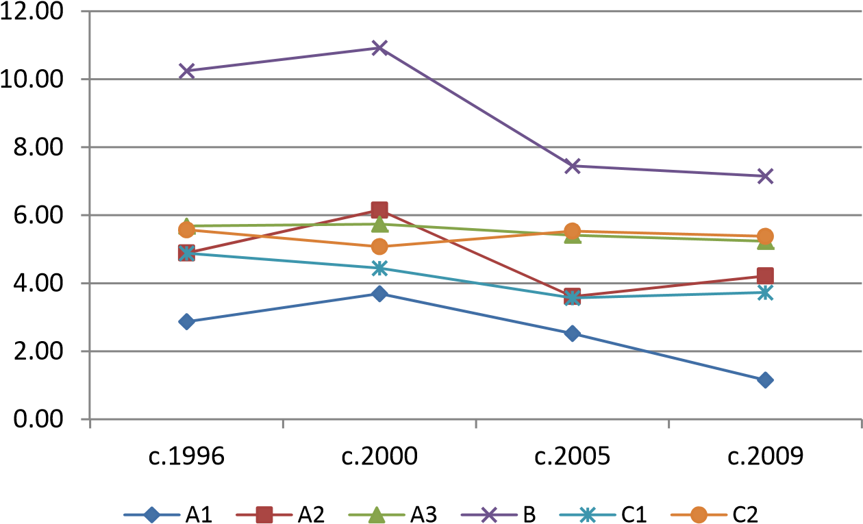

Source: COMTRADE, WTO Secretariat

For transition economies, the WTO Integrated Database offers comprehensive tariff data only from the years 2000 onwards. As depicted in Graph 9, in this country group the applied tariffs on dosified medicines (A1) have been lowered rather modestly over the past decade and are still substantive amounting to more than 8 per cent. The applied tariff level for bulk medicines (A2) reached almost 6 per cent in 2009 and the applied tariffs on specific inputs into the pharmaceutical industry (A3) was lowered from 4 to 3.3 per cent. Applied tariffs on chemical inputs of general purpose (B) was decreased slightly from 4.7 per cent to 4.4 per cent. Imposing lower tariff on inputs into the pharmaceutical industry compared to final products is an indication of a policy attempting to promote the local production of pharmaceuticals. The applied tariffs on subgroups C1 and C2 remained almost identical at around 7.2 and 5.1 per cent, respectively. Looking together at all product groups, one observes only a modest decline in applied tariffs on health products over the past decade. The overall level of tariff ranges today between 3.3 (A3) and 8.2 per cent (A1).

### Graph 9: Applied tariffs (trade weighted) by transition economies in six groups

0.00

1.00

2.00

3.00

4.00

5.00

6.00

7.00

8.00

9.00

10.00

c.2000

c.2009

c.2005

c.1996

A1

A2

A3

B

C1

C2

Source: COMTRADE, WTO Secretariat

In summary, the tariff rates applied on health products by the four country groups have decreased over the past fifteen years. In developed countries and in LDCs applied tariffs on medicines (A1 and A2) seem to be either zero or negligibly low, whereas in developing countries and transition economies they apparently still play an important role. All four country groups keep applied tariffs between 3.2 and 7.3 per cent on chemical inputs of general purpose (B). As for C1 (hospital and laboratory inputs) and C2 (medical technology equipment), all country groups apply higher tariffs for C1 than C2, except for LDCs. It is not straightforward to explain this observation, as C2 contains more final products than C1 and in case of tariff escalation should have the higher tariff level. Overall, we observe that applied tariffs on health products are low, however, in all country groups there is room for further lowering tariffs and thus for improving access.

Instead of studying country groups, one might be interested in knowing the level of applied tariff levied by individual countries. Table 2 lists the ten countries which apply the highest import duties on health products in the six product (sub) groups. For dosified medicines (A1) Nepal, Morocco, Pakistan, the Russian Federation and India impose tariffs above 10 per cent. Bulk medicines are subject to tariffs above 10 per cent in Morocco, Dijbouti, Nepal and Ghana. Dijbouti leads the list of A3 products, imposing custom duties of 26 per cent. Eight out of ten countries in subgroup A3 are located in Africa. This finding becomes even starker for group B, where all top ten countries are in Africa, with Dijbouti, Rwanda and Algeria ranging at the top of the list. Dijbouti is also at the top of the list for medical technologies (C1 and C2). For the two subgroup, five countries levy custom duties above ten per cent. Overall, we observe that some countries appear in several rankings, such as Ghana which is present in all six categories; Dijbouti comes up five time and is often ranked at the top; Maldives and Rwanda are listed four times. It seems difficult to understand why these rather small countries maintain relatively high tariffs on health products and thereby pushing up domestic prices for these products. This is even more surprising when considering that these countries have no or only a small domestic production of these goods.

*Table 2: Countries with highest applied tariffs (simple average) on health products (A1, A2, A3, B, C1, C2), latest available year.*

|  |  |  |  |  |  |  |  |  |
| --- | --- | --- | --- | --- | --- | --- | --- | --- |
| **Country** | **Group** | **2009\*** | **Country** | **Group** | **2009\*** | **Country** | **Group** | **2009\*** |
| Nepal | A1 | 14.44 | Morocco | A2 | 19.86 | Djibouti | A3 | 26.00 |
| Morocco | A1 | 14.24 | Djibouti | A2 | 11.13 | Algeria | A3 | 15.00 |
| Pakistan | A1 | 11.82 | Nepal | A2 | 11.11 | Rwanda | A3 | 15.00 |
| Russian Fed. | A1 | 10.71 | Ghana | A2 | 10.00 | Cuba | A3 | 10.23 |
| India | A1 | 10.00 | Peru | A2 | 9.00 | Ghana | A3 | 10.00 |
| Belarus | A1 | 9.44 | Pakistan | A2 | 8.89 | Tunisia | A3 | 10.00 |
| Peru | A1 | 9.00 | India | A2 | 8.75 | Gambia | A3 | 10.00 |
| Ghana | A1 | 8.89 | Mexico | A2 | 8.33 | Maldives | A3 | 10.00 |
| Nigeria | A1 | 8.75 | Argentina | A2 | 8.11 | Kenya | A3 | 9.55 |
| Argentina | A1 | 8.27 | Brazil | A2 | 8.11 | Cambodia | A3 | 9.28 |

|  |  |  |  |  |  |  |  |  |
| --- | --- | --- | --- | --- | --- | --- | --- | --- |
| **Country** | **Group** | **2009\*** | **Country** | **Group** | **2009\*** | **Country** | **Group** | **2009\*** |
| Djibouti | B | 26.00 | Djibouti | C1 | 18.43 | Djibouti | C2 | 26.00 |
| Rwanda | B | 15.00 | Morocco | C1 | 14.64 | Rwanda | C2 | 19.09 |
| Algeria | B | 14.73 | Pakistan | C1 | 13.50 | Maldives | C2 | 15.50 |
| Maldives | B | 11.78 | Ghana | C1 | 11.74 | Madagascar | C2 | 10.31 |
| Ghana | B | 10.00 | Algeria | C1 | 10.63 | Cuba | C2 | 10.16 |
| Tunisia | B | 10.00 | Tunisia | C1 | 9.92 | Ghana | C2 | 10.00 |
| Chad | B | 9.93 | Rwanda | C1 | 9.78 | Brazil | C2 | 8.92 |
| Cameroon | B | 9.86 | Maldives | C1 | 9.57 | Algeria | C2 | 8.82 |
| Cent.Afr.Rep | B | 9.80 | India | C1 | 9.46 | Venezuela | C2 | 7.94 |

*or closest year.

Source: IDB (2011)

As explained in the introductory paragraph, a distinction needs to be made between applied and bound tariffs, the latter being the level of trade opening that WTO Members have committed to at the multilateral level. It is interesting to compare the level of bound tariffs with the level of applied tariffs (simple average) in 2009 (or latest year) across the four country groups (Graph 10).

In developed countries the bound level is very close to the applied rate in absolute terms, except for product group B (3.2 per cent compared to 1.4 per cent). The picture looks substantially different for developing countries and LDCs. Developing countries have bound their tariffs on all health products substantially above 20 per cent. As explained, high bound rates do not imply that high tariffs are actually charged, however, they offer Members the possibility to increase their applied rates up to the bound level. (A higher level than the bound rates could result in compensation for trading partners' loss of trade). Reducing the bound rates closer to the applied rate would provide an important signal to traders that tariffs will remain at low levels and therefore provide more predictability to both exporters and importers. For LDCs the bound rate is even higher reaching the level of around 40 per cent for all product groups, except for A3 which is bound above 60 per cent. Currently, only one transition countries, namely Albania, is WTO Members and has reported its tariffs. The applied and final bound rates are similar and show small absolute gaps.[7]

### Graph 10: Bound versus applied tariffs (simple average) by developed, developing and LDCs in all six groups

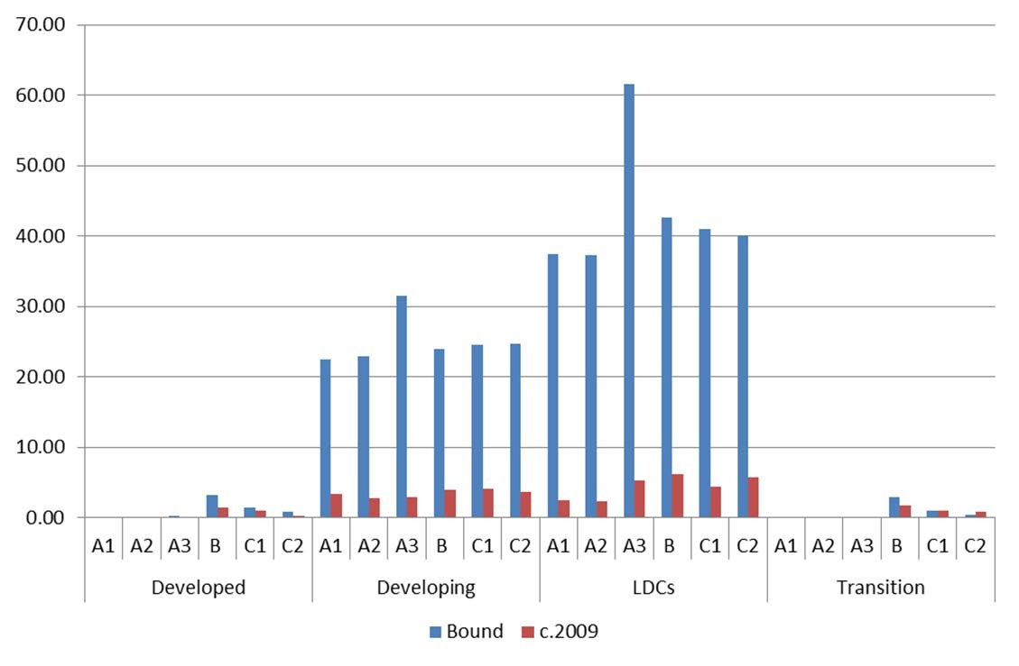

### Source: COMTRADE, WTO Secretariat

#### **2. Preferential tariffs and tariff concessions**

The above tariff analysis is based on tariff concessions that WTO Members grant at the multilateral level. WTO Members are allowed under certain conditions to conclude preferential trade agreements among themselves and also with non-Members. As the name already indicates, preferential trade agreements offer a level of market entry which is more favourable than the one committed at the multilateral level. As a consequence, the customs duties applied to imports from PTA partners are usually lower than the ones applied towards non-PTA partners. This section attempts to presents evidence of preferential tariffs applied by developing countries on health and health-related products for imports from other developing countries. We only include developing countries in our sample, as a large proportion of developed countries already grant duty-free or close to duty-free market access to imports on health and health-related products as we have seen above.

Preferential tariff data is rather difficult to obtain and it is not systematically notified to any international organization. The International Trade Centre (ITC) in Geneva has recently undertaken major efforts to collect the preferential tariff rates of major developing country exporters. In this section, we present the preferential tariff data collected by ITC as they apply to health products.

Looking at the aggregate level (Table 3), we observe that the preferential tariffs on all three product groups (A, B, and C) have decreased between 2005 and 2009. In 2009, the average preferential tariff rate for all three groups was below 5 per cent. Second, within the four years, the preferential tariff rates have declined in every product group more rapidly than the MFN rates and thus widened the gap between the preferential and MFN treatment (third and sixth column lists the difference between the tariff rate in 2005 and 2009). Third, the ordering between the three groups remains the same, with the lowest tariffs applied on medicines (A) and the highest tariffs for medical devices (C).

#### Table 3: Average import tariffs levied by selected developing countries on health products (A, B and C)

|  |  |  |  |  |  |  |  |
| --- | --- | --- | --- | --- | --- | --- | --- |
|  |  | AVERAGE PREF. | | | AVERAGE MFN | | |
| 2005 | 2009 | *Differ.* | 2005 | 2009 | *Differ.* |
| A | Weighted by trade | 4.2% | 3.2% | *-1.0%* | 4.6% | 3.8% | *-0.7%* |
|  | Simple average | 4.5% | 3.5% | *-1.0%* | 4.8% | 3.9% | *-0.8%* |
| B | Weighted by trade | 5.4% | 3.5% | *-2.0%* | 6.1% | 4.4% | *-1.7%* |
|  | Simple average | 5.4% | 3.6% | *-1.8%* | 6.2% | 4.6% | *-1.6%* |
| C | Weighted by trade | 6.3% | 4.7% | *-1.6%* | 6.7% | 5.3% | *-1.4%* |
|  | Simple average | 5.9% | 4.7% | *-1.2%* | 6.3% | 5.3% | *-1.0%* |

### Source: ITC, WTO Secretariat

At the individual country level (and at the aggregate goods level), the pictures becomes more nuanced (Table 4):

#### Table 4: Import tariffs levied by selected developing countries on health products (A, B and C)

|  |  |  |  |  |  |  |  |
| --- | --- | --- | --- | --- | --- | --- | --- |
|  |  | AVERAGE PREF. | | | AVERAGE MFN | | |
| 2005 2009 *Differ.* | | | 2005 2009 *Differ.* | | |
| Brazil | Weighted by trade | 6.6% | 7.2% | *0.7%* | 7.3% | 7.9% | *0.6%* |
|  | Simple average | 6.4% | 6.5% | *0.1%* | 7.2% | 7.4% | *0.2%* |
| China | Weighted by trade | 4.9% | 3.1% | *-1.8%* | 5.0% | 5.4% | *0.4%* |
|  | Simple average | 5.1% | 5.1% | *0.0%* | 5.1% | 5.9% | *0.8%* |
| Mexico | Weighted by trade | 7.9% | 5.4% | *-2.5%* | 8.6% | 6.0% | *-2.5%* |
|  | Simple average | 8.5% | 5.9% | *-2.6%* | 9.4% | 7.0% | *-2.5%* |
| Ch. Taipei | Weighted by trade | 1.5% | 1.9% | *0.4%* | 1.5% | 2.0% | *0.4%* |
|  | Simple average | 1.4% | 1.7% | *0.3%* | 1.4% | 1.8% | *0.4%* |
| India | Weighted by trade | 14.9% 8.1% *-6.8%* | | | 14.9% 8.5% *-6.4%* | | |
|  | Simple average | 14.7% 7.8% *-6.9%* | | | 14.9% 8.3% *-6.7%* | | |
| South Africa | Weighted by trade | 1.4% 1.0% *-0.4%* | | | 1.4% 1.0% *-0.4%* | | |
|  | Simple average | 1.1% 1.0% *-0.1%* | | | 1.2% 1.1% *-0.1%* | | |
| Turkey | Weighted by trade | 0.6% 0.5% *-0.1%* | | | 2.1% 1.8% *-0.2%* | | |
|  | Simple average | 0.4% 0.4% *-0.1%* | | | 1.9% 1.8% *0.0%* | | |

### Source: ITC, WTO Secretariat

According to the tariff data reported by ITC, Brazil has levied higher preferential and MFN tariffs on health products in 2009 compared to 2005. Comparing the trade-weighted tariff rates and the simple tariff rates, the results indicate that the tariff lines with high volumes of trade were particularly affected by the tariff increase. Similarly, China has increased their applied MFN tariffs from 2005 to 2009 and seemingly on tariff lines that were less traded (increase in simple average higher than increase in weighted average). On the other hand, China has substantially lowered its preferential tariff rates, especially on strongly trade tariff lines.

Mexico lowered by 2.5 per cent both tariffs, MFN and preferential. Chinese Taipei applies very low tariffs (below two per cent) on imports from both, preferential and MFN partners. It is interesting to observe that preferential and MFN rates have increased from 2005 to 2009. Despite the increase, the overall tariff level for health products remains very low in Chinese Taipei.

India is the country with the highest tariffs (both MFN and preferential) on health products in our sample. However, India is also the country which has lowered most drastically (in relative and absolute terms) its tariffs over the past five years. The difference between MFN and preferential rates is small in the case of India.

Like Chinese Taipei, South Africa maintains very low tariff levels on import of health product. The tariffs, both MFN and preferential, have been further reduced to around 1 per cent in 2009. In our sample, Turkey is the country with the lowest preferential tariffs in 2005 and 2009. From 2005 to 2009, Turkey has further reduced their tariffs and offers today a high degree of market access, especially for preferential trading partners.

In summary, analysing preferential tariffs we observe that tariffs are indeed lower compared to MFN, however, the difference does not exceed 1 per cent. Studying individual countries, the tariff level for health products, both preferential and MFN, differs substantially between countries. While for example Chinese Taipei and South Africa maintain low tariff rates, India imposes substantially higher tariff rates on trade towards the rest of the world as well as preferential trading partners. However, the difference between preferential rates and MFN is often small (below) 1 per cent and is biggest for case of China in 2009 (2.2 per cent lower tariffs).

### **IV. CONCLUSION**

The first objective of this paper has been to establish a group of commodities based on the HS classification that are all important goods (as inputs or final products) entering the public health sphere. We suggest three commodity groups and five commodity subgroups to capture all international trade flows relevant for public health.

The paper then gave an overview of the corresponding international trade flows from 1995 to 2009. We found that the international trade in health products have grown in a very dynamic way, especially trade in dosified and bulk medicines. Our results further indicate that international trade in health products is strongly dominated by trade among a small number of developed countries. Studying detailed tariff data at the multilateral level, we show that the tariff level has decreased significantly over the past fifteen years and is on average well below ten per cent. Tariffs in preferential trade arrangements are even lower.

Overall, tariffs on health products have come down substantially over the past years, and in many countries tariffs on health products are probably among the smaller obstacles for access to health. As a corollary, in the majority of countries applied tariffs are not used anymore as an instrument of industrial policy. One reason might be that the production of pharmaceutical and of medical devices typically requires a certain degree of technical sophistication which cannot be easily created or promoted. However, given these difficulties and the already low level of tariffs, the question to ask is why countries even maintain tariffs on health products. Imposing tariffs typically translates into higher product prices, especially in presence of long supply changes. Maintaining tariffs ultimaty means taxing the sick and creating additional costs for the health system.

Reducing the gap between international prices and domestic prices by lowering tariffs would therefore not only be a positive development for patients, but also for all health service providers that rely on cheap inputs of health products. In addition, lower prices for specific and general chemical inputs into the pharmaceutical industry (groupings A3 and B1) can also help promoting the competitiveness of the local pharmaceutical industry.

As several studies indicate, there are various factors that determine the domestic price of internationally traded health products (e.g. Cameron et al. 2011). These factors might include pricing strategies of the manufacturers, tariffs and non-tariff barriers, transportation and distribution costs, domestic taxes and other mark-up costs. Import tariffs levied on the value of an imported good thus constitute only one cost element. However, they can substantively alter the price of both, the final products as well as of intermediated inputs. In this paper, we only focus on tariffs and neglect other price determinants. In a study by Bate & Tren (2005), the authors combine tariff data with data on value added tax and other duties and find that all duties taken together constituted a major impediment for access to medicine.

Another topic for future research could be to analyse special import regimes for health products. Many countries exempt certain products from customs duties for various reasons, for example the government or international agencies often do not pay import duties on products imported for official purposes. Krasovec & Connor (1998) mention several countries that provide such tariff exemptions for public health commodities, especially the products are purchased by a non-profit buyer. In order to be able to evaluate the effect of such duty exemptions in a systematic way, one would need very detailed import data which specify for every import flow whether a duty was paid or not. The World Bank has recently launched the Tariff Reform Impact Simulation Tool (TRIST) which attempts to estimate the impact of trade reforms on trade flows by using highly disaggregated trade flows. Due to this new tool,[8] detailed national data is available with the necessary level of disaggregation.[9] As an extension of this paper, it would certainly be worthwhile retrieving this type of information and providing an in-depth analysis.

As indicated above, tariff data give only limited insights into the final price of health products in the importing countries, as other cost elements might play an important role.[10] Looking only at tariffs in isolation, one is unable to make predictions about final prices in countries, even less to make comparisons across countries. From a trade perspective, lowering tariffs should result in lower prices and thus an increased demand for health products. Instead of thus looking at the absolute price level, one interesting research question would be to verify whether the decrease in tariffs has resulted in larger amounts of importations.11 If lowering prices has indeed led to more imports, the question asked in the title of this paper would probably have a positive answer.

### **V. REFERENCES**

Bate, R., Tren, R., & Urbach, J. (2005). Taxed to Death. AEI-Brookings Joint Center for Regulatory Studies. (April 2005), online:

http://www.fightingmalaria.org/pdfs/taxed_to_death1.pdf.

Cameron, A., Ewen, M., Auton, M., & Abegunde, D. (2011). The World Medicines Situation 2011: Medicines Prices, Availability and Affordability. World Health Organization. Geneva.

IMS. (2011). The Global Use of Medicines: Outlook Through 2015. Report by the IMS Institute for Healthcare Informatics (May).

Krasovec, K., & Connor, C. (1998). Using Tax Relief to Support Public Health Goals, (September). Partners for Health Reformplus. Online:

http://www.phrplus.org/Pubs/pib21.pdf

Olcay, M., & Laing, R. (2005). Pharmaceutical Tariffs: What is their effect on prices, protection of local industry and revenue generation?, Study prepared for the Commission on Intellectual Property Rights, Innovation and Public Health. World Health.

Simon, J. L., Larson, B. A., Zusman, A., & Rosen, S. (2002). Policy and Practice How will the reduction of tariffs and taxes on insecticide- treated bednets affect household purchases ? Bulletin of the World Health Organization, 80(01).

World Health Organization (2001). How to Develop and Implement a National Drug Policy.

World Health Organization. Geneva. Online:

http://apps.who.int/medicinedocs/pdf/s2283e/s2283e.pdf

11

In order to test this hypothesis one might construct a simple econometric model, which stipulates that the change in imports is explained by a change in tariffs. Higher imports might not only stem from lower tariffs, but demand might have increased for other reasons, such as higher private and public spending for health care or a changing age structure. In order to controll for these changes, one would need to introduce into the econometric three additional variables, namely the change in per capita income (GDP/Pop), the change in public health spending per capita (HeX/Pop) and finally the change in life expectancy (Lexp). The equation to be estimated could take the following form (all variables are included for all countries, i, in the sample. ε constitutes the error term):

∆im = α + ∆(tariff ) + ∆ + ∆ + ∆Lexp + ε

**VI. APPENDIX**

## A. APPENDIX 1: LIST OF HS SUBHEADINGS INCLUDED IN THE SAMPLE

|  |  |  |  |  |
| --- | --- | --- | --- | --- |
| Nr | HS Code  6 digit | Group | Description | Old |
| 1 | 300220 | A1 | Vaccines for human medicine |  |
| 2 | 300410 | A1 | Medicaments containing penicillins or derivatives thereof with a penicillanic acid structure, or streptomycins or derivatives thereof, put up in measured doses "incl. those in the form of transdermal administration" or in forms or packings for retail sale |  |
| 3 | 300420 | A1 | Medicaments containing antibiotics, put up in measured doses "incl. those in the form of transdermal administration" or in forms or packings for retail sale (excl. medicaments containing penicillins or derivatives thereof with a penicillanic structure, or streptomycines or derivatives thereof) |  |
| 4 | 300431 | A1 | Medicaments containing insulin but not antibiotics, put up in measured doses "incl. those in the form of transdermal administration" or in forms or packings for retail sale |  |
| 5 | 300432 | A1 | Medicaments containing corticosteroid hormones, their derivatives or structural analogues but not antibiotics, put up in measured doses "incl. those in the form of transdermal administration" or in forms or packings for retail sale |  |
| 6 | 300439 | A1 | Medicaments containing hormones or steroids used as hormones but not antibiotics, put up in measured doses "incl. those in the form of transdermal administration" or in forms or packings for retail sale (excl. medicaments containing insulin or corticosteroid hormones, their derivatives or structural analogues) |  |
| 7 | 300440 | A1 | Medicaments containing alkaloids or derivatives thereof, not containing hormones, steroids used as hormones or antibiotics, put up in measured doses "incl. those in the form of transdermal administration" or in forms or packings for retail sale |  |
| 8 | 300450 | A1 | Medicaments containing provitamins, vitamins, incl. natural concentrates and derivatives thereof used primarily as vitamins, put up in measured doses "incl. those in the form of transdermal administration" or in forms or packings for retail sale |  |
| 9 | 300490 | A1 | Medicaments consisting of mixed or unmixed products for therapeutic or prophylactic purposes, put up in measured doses "incl. those in the form of transdermal administration" or in forms or packings for retail sale (excl. medicaments containing antibiotics, medicaments containing hormones or steroids used as hormones, but not containing antibiotics, medicaments containing alkaloids or derivatives thereof but not containing hormones or antibiotics and medicaments containing provitamins, vitamins or derivatives thereof used as vitamins) |  |
| 10 | 300310 | A2 | Medicaments containing penicillins or derivatives thereof with a penicillanic acid structure, or streptomycins or derivatives thereof, not in measured doses or put up for retail sale |  |
| 11 | 300320 | A2 | Medicaments containing antibiotics, not in measured doses or put up for retail sale (excl. medicaments containing penicillins or derivatives thereof with a penicillanic acid structure, or streptomycins or derivatives thereof) |  |
| 12 | 300331 | A2 | Medicaments containing insulin, not in measured doses or put up for retail sale |  |
| 13 | 300339 | A2 | Medicaments containing hormones or steroids used as hormones, not containing antibiotics, not in measured doses or put up for retail sale (excl. those containing insulin) |  |
| 14 | 300340 | A2 | Medicaments containing alkaloids or derivatives thereof, not containing hormones, steroids used as hormones or antibiotics, not in measured doses or put up for retail sale |  |
| 15 | 300390 | A2 | Medicaments consisting of two or more constituents mixed together for therapeutic or prophylactic uses, not in measured doses or put up for retail sale (excl. antibiotics containing hormones or steroids used as hormones, but not containing antibiotics, alkaloids or derivatives thereof, hormones or antibiotics, or goods of heading 3002, 3005 or 3006) |  |
| 16 | 300660 | A2 | Chemical contraceptive preparations based on hormones, prostaglandins, thromboxanes, leukotrienes, derivatives and structural analogues thereof or on spermicides |  |
| 17 | 293610 | A3 | Provitamins, unmixed | * |
| 18 | 293621 | A3 | Vitamins A and their derivatives, used primarily as vitamins |  |
| 19 | 293622 | A3 | Vitamin B1 and its derivatives, used primarily as vitamins |  |
| 20 | 293623 | A3 | Vitamin B2 and its derivatives, used primarily as vitamins |  |
| 21 | 293624 | A3 | D-Pantothenic or DL-pantothenic acid "Vitamin B3 or B5" and their derivatives, used primarily as vitamins |  |

|  |  |  |  |  |
| --- | --- | --- | --- | --- |
| 22 | 293625 | A3 | Vitamin B6 and its derivatives, used primarily as vitamins |  |
| 23 | 293626 | A3 | Vitamin B12 and its derivatives, used primarily as vitamins |  |
| 24 | 293627 | A3 | Vitamin C and its derivatives, used primarily as vitamins |  |
| 25 | 293628 | A3 | Vitamin E and its derivatives, used primarily as vitamins |  |
| 26 | 293629 | A3 | Vitamins and their derivatives, used primarily as vitamins, unmixed (excl. vitamins A, B1, B2, B3, B5, B6, B12, C, E and their derivatives) |  |
| 27 | 293690 | A3 | Provitamins and mixtures of vitamins, of provitamins or of concentrates, whether or not in any solvent, and natural concentrates |  |
| 28 | 293710 | A3 | Pituitary "anterior" or similar hormones, and derivatives, used primarily as hormones | * |
| 29 | 293711 | A3 | Somatropin, its derivatives and structural analogues, used primarily as hormones |  |
| 30 | 293712 | A3 | Insulin and its salts, used primarily as hormones |  |
| 31 | 293719 | A3 | Polypeptide hormones, protein hormones and glycoprotein hormones, their derivatives and structural analogues, used primarily as hormones (excl. somatropin, its derivatives and structural analogues, and insulin and its salts) |  |
| 32 | 293721 | A3 | Cortisone, hydrocortisone, prednisone "dehydrocortisone" and prednisolone "dehydrohydrocortisone" |  |
| 33 | 293722 | A3 | Halogenated derivatives of corticosteroidal hormones |  |
| 34 | 293723 | A3 | Oestrogens and progestogens |  |
| 35 | 293729 | A3 | Steroidal hormones, their derivatives and structural analogues, used primarily as hormones (excl. cortisone, hydrocortisone, prednisone "dehydrocortisone", prednisolone "dehydrohydrocortisone", halogenated derivatives of corticosteroidal hormones, oestrogens and progestogens) |  |
| 36 | 293731 | A3 | Epinephrine |  |
| 37 | 293739 | A3 | Catecholamine hormones, their derivatives and structural analogues, used primarily as hormones (excl. epinephrine) |  |
| 38 | 293740 | A3 | Amino-acid derivatives, used primarily as hormones |  |
| 39 | 293750 | A3 | Prostaglandins, thromboxanes and leukotrienes, their derivatives and structural analogues, used primarily as hormones |  |
| 40 | 293790 | A3 | Hormones, natural or reproduced by synthesis; derivatives and structural analogues thereof, used primarily as hormones (excl. polypeptide hormones, protein hormones, glycoprotein hormones, steroidal hormones, catecholamine hormones, prostaglandins, thromboxanes and leukotrienes, their derivatives and structural analogues, and aminoacid derivatives) |  |
| 41 | 293791 | A3 | Insulin and its salts | * |
| 42 | 293792 | A3 | Oestrogens and progestogens | * |
| 43 | 293799 | A3 | Hormones and their derivatives used primarily as hormones (excl. pituitary "anterior" or similar hormones and their derivatives, adrenal cortical hormones and their derivatives, insulin and its salts, oestrogens and progestogens) | * |
| 44 | 293910 | A3 | Alkaloids of opium and their derivatives; salts thereof | * |
| 45 | 293911 | A3 | Concentrates of poppy straw; buprenorphine "INN", codeine, dihydrocodeine "INN", ethylmorphine, etorphine "INN", heroin, hydrocodone "INN", hydromorphone "INN", morphine, nicomorphine "INN", oxycodone "INN", oxymorphone "INN", pholcodine "INN", thebacon "INN" and thebaine, and salts thereof |  |
| 46 | 293919 | A3 | Alkaloids of opium and their derivatives, and salts thereof (excl. concentrates of poppy straw; buprenorphine "INN", codeine, dihydrocodeine "INN", ethylmorphine, etorphine "INN", heroin, hydrocodone "INN", hydromorphone "INN", morphine, nicomorphine "INN", oxycodone "INN", oxymorphone "INN", pholcodine "INN", thebacon "INN" and thebaine, and salts thereof) |  |
| 47 | 293920 | A3 | Alkaloids of cinchona and their derivatives; salts thereof |  |
| 48 | 293921 | A3 | Quinine and its salts | * |
| 49 | 293929 | A3 | Alkaloids of cinchons and their derivatives; salts thereof (excl. quinine and its salts) | * |
| 50 | 293930 | A3 | Caffeine and its salts |  |
| 51 | 293940 | A3 | Ephedrines and their salts | * |
| 52 | 293941 | A3 | Ephedrine and its salts |  |
| 53 | 293942 | A3 | Pseudoephedrine "INN" and its salts |  |

|  |  |  |  |  |
| --- | --- | --- | --- | --- |
| 54 | 293943 | A3 | Cathine "INN" and its salts |  |
| 55 | 293949 | A3 | Ephedrines and their salts (excl. ephedrine, pseudoephedrine "INN", cathine "INN", and salts thereof) |  |
| 56 | 293950 | A3 | Theophylline and aminophylline "theophylline-ethylenediamine" and their derivatives; salts thereof | * |
| 57 | 293951 | A3 | Fenetylline "INN" and its salts |  |
| 58 | 293959 | A3 | Theophylline and aminophylline "theophylline-ethylenediamine" and their derivatives, and salts thereof (excl. fenetylline "INN" and its salts) |  |
| 59 | 293960 | A3 | Alkaloids of rye ergot and their derivatives; salts thereof | * |
| 60 | 293961 | A3 | Ergometrine "INN" and its salts |  |
| 61 | 293962 | A3 | Ergotamine "INN" and its salts |  |
| 62 | 293963 | A3 | Lysergic acid and its salts |  |
| 63 | 293969 | A3 | Alkaloids of rye ergot and their derivatives; salts thereof (excl. lysergic acid, ergotamine and ergometrine, and their salts) |  |
| 64 | 293970 | A3 | Nicotine and its salts | * |
| 65 | 293990 | A3 | Vegetable alkaloids, natural or reproduced by synthesis, and their salts, ethers, esters and other derivatives (excl. alkaloids of opium, alkaloids of cinchons, theophylline, aminophylline "theophylline-ethylenediamine" alkaloids of rye ergot and their sa | * |
| 66 | 293991 | A3 | Cocaine, ecgonine, levometamfetamine, metamfetamine "INN", metamfetamine racemate, and salts, esters and other derivatives thereof |  |
| 67 | 293999 | A3 | Vegetable alkaloids, natural or reproduced by synthesis, and their salts, ethers, esters and other derivatives (excl. alkaloids of opium, alkaloids of cinchons, theophylline, aminophylline "theophylline-ethylenediamine" alkaloids of rye ergot and their salts and derivatives, cocaine, ecgonine, levometamfetamine, metamfetamine "INN", metamfetamine racemate, and salts, esters and other derivatives thereof caffeine and ephedrines, and their salts) |  |
| 68 | 294110 | A3 | Penicillins and their derivatives with a penicillanic acid structure; salts thereof |  |
| 69 | 294120 | A3 | Streptomycins and their derivatives; salts thereof |  |
| 70 | 294130 | A3 | Tetracyclines and their derivatives; salts thereof |  |
| 71 | 294140 | A3 | Chloramphenicol and its derivatives; salts thereof |  |
| 72 | 294150 | A3 | Erythromycin and its derivatives; salts thereof |  |
| 73 | 294190 | A3 | Antibiotics (excl. penicillins and their derivatives with a penicillanic acid structure, salts thereof, streptomycins, tetracyclines, chloramphenicol and erythromycin, their derivatives and salts thereof) |  |
| 74 | 284210 | B | Double or complex silicates of inorganic acids or peroxoacids, incl. aluminosilicates whether or not chemically defined (excl. inorganic or organic compounds of mercury) |  |
| 75 | 284290 | B | Salts of inorganic acids or peroxoacids (excl. of oxometallic or peroxometallic acids, double or complex silicates [incl. aluminosilicates whether or not chemically defined], azides, and inorganic or organic compounds of mercury) |  |
| 76 | 290290 | B | Cyclic hydrocarbons (excl. cyclanes, cyclenes, benzene, toluene, xylenes, styrene, ethylbenzene and cumene) |  |
| 77 | 290349 | B | Halogenated derivatives of acyclic hydrocarbons with two or more different halogens (excl. perhalogenated derivatives) |  |
| 78 | 290369 | B | Halogenated derivatives of aromatic hydrocarbons (excl. chlorobenzene, odichlorobenzene and p-dichlorobenzene, hexachlorobenzene [ISO] and DDT [ISO] [clofenotane [INN], "1,1,1-trichloro-2,2-bis[p-chlorophenyl]ethane") |  |
| 79 | 290410 | B | Derivatives of hydrocarbons containing only sulpho groups, their salts and ethyl esters |  |
| 80 | 290490 | B | Sulphonated, nitrated or nitrosated derivatives of hydrocarbons, whether or not halogenated (excl. those containing only sulpho, nitro or nitroso groups) |  |
| 81 | 290522 | B | Acyclic terpene alcohols |  |
| 82 | 290529 | B | Unsaturated monohydric acyclic alcohols (excl. acyclic terpene alcohols) |  |
| 83 | 290619 | B | Cyclanic, cyclenic or cycloterpenic alcohols and their halogenated, sulphonated, nitrated or nitrosated derivatives (excl. menthol, cyclohexanol, methylcyclohexanols, dimethylcyclohexanols, sterols and inositols) |  |
| 84 | 290629 | B | Aromatic cyclic alcohols and their halogenated, sulphonated, nitrated or nitrosated derivatives (excl. benzyl alcohol) |  |

|  |  |  |  |  |
| --- | --- | --- | --- | --- |
| 85 | 290729 | B | Polyphenols and phenol-alcohols (excl. resorcinol and hydroquinone "quinol" and their salts, and 4,4''-isopropylidenediphenol "bisphenol A, diphenylolpropane" and its salts) |  |
| 86 | 290919 | B | Acyclic ethers and their halogenated, sulphonated, nitrated or nitrosated derivatives (excl.  diethyl ether) |  |
| 87 | 290930 | B | Aromatic ethers and their halogenated, sulphonated, nitrated or nitrosated derivatives |  |
| 88 | 290949 | B | Ether-alcohols and their halogenated, sulphonated, nitrated or nitrosated derivatives (excl. 2,2''-Oxydiethanol "diethylene glycol, digol" and monoalkylethers of ethylene glycol or of diethylene glycol) |  |
| 89 | 290950 | B | Ether-phenols, ether-alcohol-phenols and their halogenated, sulphonated, nitrated or nitrosated derivatives |  |
| 90 | 291229 | B | Cyclic aldehydes, without other oxygen function (excl. benzaldehyde) |  |
| 91 | 291249 | B | Aldehyde-ethers, aldehyde-phenols and aldehydes with other oxygen function (excl. ethylvanillin "3-ethoxy-4-hydroxybenzaldehyde" and vanillin "4-hydroxy-3methoxybenzaldehyde") |  |
| 92 | 291419 | B | Acyclic ketones, without other oxygen function (excl. acetone, butanone "methyl ethyl ketone" and 4-Methylpentan-2-one "Methyl isobutyl ketone") |  |
| 93 | 291440 | B | Ketone-alcohols and ketone-aldehydes |  |
| 94 | 291469 | B | Quinones (excl. anthraquinone) |  |
| 95 | 291539 | B | Esters of acetic acid (excl. ethyl, vinyl, n-butyl and dinoseb [ISO] acetates) |  |
| 96 | 291550 | B | Propionic acid, its salts and esters |  |
| 97 | 291590 | B | Saturated acyclic monocarboxylic acids, their anhydrides, halides, peroxides and peroxyacids; their halogenated, sulphonated, nitrated or nitrosated derivatives (excl. formic acid and acetic acid, mono-, di- or trichloroacetic acids, proprionic acid, butanoic and pentanoic acids, palmitic and stearic acids, their salts and esters, and acetic anhydride) |  |
| 98 | 291619 | B | Unsaturated acyclic monocarboxylic acids, their anhydrides, halides, peroxides, peroxyacids and halogenated, sulphonated, nitrated or nitrosated derivatives (excl. acrylic acid and its salts and esters, methacrylic acid and its salts and esters, and oleic, linoleic or linolenic acids, their salts and esters) |  |
| 99 | 291620 | B | Cyclanic, cyclenic or cycloterpenic monocarboxylic acids, their anhydrides, halides, peroxides, peroxyacids and their halogenated, sulphonated, nitrated or nitrosated derivatives (excl. inorganic or organic compounds of mercury) |  |
| 100 | 291639 | B | Aromatic monocarboxylic acids, their anhydrides, halides, peroxides, peroxyacids and their halogenated, sulphonated, nitrated or nitrosated derivatives (excl. benzoic acid, its salts and esters, benzoyl peroxide, benzoyl chloride, binapacryl [ISO], phenylacetic acid, its salts and esters, and inorganic or organic compounds of mercury) |  |
| 101 | 291713 | B | Azelaic acid, sebacic acid, their salts and esters |  |
| 102 | 291719 | B | Acyclic polycarboxylic acids, their anhydrides, halides, peroxides, peroxyacids and their halogenated, sulphonated, nitrated or nitrosated derivatives (excl. oxalic acid, its salts and esters, adipic acid, its salts and esters, azelaic acid, sebacic acid, their salts and esters, maleic anhydride, and inorganic or organic compounds of mercury) |  |
| 103 | 291734 | B | Esters of orthophthalic acid (excl. dioctyl, dinonyl or didecyl orthophthalates) |  |
| 104 | 291739 | B | Aromatic polycarboxylic acids, their anhydrides, halides, peroxides, peroxyacids and their halogenated, sulphonated, nitrated or nitrosated derivatives (excl. esters of orthophthalic acid, phthalic anhydride, terephthalic acid and its salts and dimethyl terephthalate) |  |
| 105 | 291811 | B | Lactic acid, its salts and esters (excl. inorganic or organic compounds of mercury) |  |
| 106 | 291813 | B | Salts and esters of tartaric acid |  |
| 107 | 291816 | B | Gluconic acid, its salts and esters |  |
| 108 | 291819 | B | Carboxylic acids with additional oxygen function and their anhydrides, halides, peroxides and peroxyacids; their halogenated, sulphonated, nitrated or nitrosated derivatives (excl. lactic acid, tartaric acid, citric acid, gluconic acid and their salts and esters, and chlorobenzilate [ISO]) |  |
| 109 | 291822 | B | o-Acetylsalicylic acid, its salts and esters |  |
| 110 | 291823 | B | Esters of salicylic acid and their salts (excl. o-acetylsalicylic acid, its salts and esters) |  |
| 111 | 291829 | B | Carboxylic acids with phenol function but without other oxygen function, their anhydrides, halides, peroxides, peroxyacids and their halogenated, sulphonated, nitrated or nitrosated derivatives (excl. salicylic acid and o-Acetylsalicylic acid, and their salts and esters) |  |

|  |  |  |  |  |
| --- | --- | --- | --- | --- |
| 112 | 291830 | B | Carboxylic acids with aldehyde or ketone function but without other oxygen function, their anhydrides, halides, peroxides, peroxyacids and their halogenated, sulphonated, nitrated or nitrosated derivatives |  |
| 113 | 292090 | B | Esters of other inorganic acids of non-metals and their salts; their halogenated, sulphonated, nitrated or nitrosated derivatives (excl. esters of hydrogen halides, and thiophosphoric esters "phosphorothioates", their salts and their halogenated, sulphonated, nitrated or nitrosated derivatives, and inorganic or organic compounds of mercury)) |  |
| 114 | 292119 | B | Acyclic monoamines and their derivatives; salts thereof (excl. methylamine, dimethylamine, trimethylamine, and their salts) |  |
| 115 | 292129 | B | Acyclic polyamines and their derivatives; salts thereof (excl. ethylenediamine and hexamethylenediamine, and their salts) |  |
| 116 | 292130 | B | Cyclanic, cyclenic or cycloterpenic mono- or polyamines, and their derivatives; salts thereof |  |
| 117 | 292142 | B | Aniline derivatives and their salts |  |
| 118 | 292149 | B | Aromatic monoamines and derivatives; salts thereof (excl. aniline, toluidines, diphenylamine, 1-naphthylamine "alpha-naphthylamine", 2-naphthylamine "betanaphthylamine" and their derivatives, and salts thereof, and amfetamine "INN", benzfetamine "INN", dexamfetamine "INN", etilamfetamine "INN", fencamfamine "INN", lefetamine "INN", levamfetamine "INN", mefenorex "INN" and phentermine "INN", and salts thereof) |  |
| 119 | 292159 | B | Aromatic polyamines and their derivatives; salts thereof (excl. o-phenylenediamine, mphenylenediamine, p-phenylenediamine or diaminotoluenes and their derivatives, and salts thereof) |  |
| 120 | 292211 | B | Monoethanolamine and its salts |  |
| 121 | 292219 | B | Amino-alcohols, their ethers and esters; salts thereof (other than those containing > one kind of oxygen function and excl. monoethanolamine, diethanolamine, triethanolamine, dextropropoxyphene "INN", and salts thereof) |  |
| 122 | 292229 | B | Amino-naphthols and other amino-phenols, their ethers and esters; salts thereof (excl. those containing > one kind of oxygen function; aminohydroxynaphthalenesulphonic acids and their salts) |  |
| 123 | 292241 | B | Lysine and its esters; salts thereof |  |
| 124 | 292249 | B | Amino-acids and their esters; salts thereof (excl. those with > one kind of oxygen function, lysine and its esters, and salts thereof, and glutamic acid, anthranilic acid, tilidine "INN", and salts thereof) |  |
| 125 | 292250 | B | Amino-alcohol-phenols, amino-acid-phenols and other amino-compounds with oxygen function (excl. amino-alcohols, amino-naphthols and other amino-phenols, their ethers and esters and salts thereof, amino-aldehydes, amino-ketones and amino-quinones, and salts thereof, amino-acids and their esters and salts thereof) |  |
| 126 | 292310 | B | Choline and its salts |  |
| 127 | 292390 | B | Quaternary ammonium salts and hydroxides (excl. choline and its salts) |  |
| 128 | 292429 | B | Cyclic amides, incl. cyclic carbamates, and their derivatives; salts thereof (excl. ureines and their derivatives, salts thereof, 2-acetamidobenzoic acid "N-acetylanthranilic acid" and its salts and ethinamate "INN") |  |
| 129 | 292519 | B | Imides and their derivatives; salts thereof (excl. saccharin and its salts, glutethimide [INN] and inorganic or organic compounds of mercury) |  |
| 130 | 292690 | B | Nitrile-function compounds (excl. acrylonitrile, 1-cyanoguanidine "dicyandiamide", fenproporex "INN" and its salts, and methadone "INN"-intermediate "4-cyano-2dimethylamino-4,4-diphenylbutane") |  |
| 131 | 292700 | B | Diazo-, azo- or azoxy-compounds |  |
| 132 | 292800 | B | Organic derivatives of hydrazine or of hydroxylamine |  |
| 133 | 292990 | B | Compounds with nitrogen function (excl. amine-function compounds; oxygen-function amino-compounds; quaternary ammonium salts and hydroxides; lecithin and other phosphoaminolipids; carboxyamide-function compounds; amide-function compounds of carbonic acid; carboxyimide-function, imine-function or nitrile-function compounds; diazo-, azo- or azoxy-compounds; organic derivatives of hydrazine or of hydroxylamine and isocyanates) |  |
| 134 | 293090 | B | Organo-sulphur compounds (excl. thiocarbamates and dithiocarbamates, thiuram mono-, di- or tetrasulphides, methionine, captafol [ISO] and methamidophos [ISO]) |  |
| 135 | 293100 | B | Separate chemically defined organo-inorganic compounds (excl. organo-sulphur compounds and those of mercury) |  |

|  |  |  |  |  |
| --- | --- | --- | --- | --- |
| 136 | 293299 | B | Heterocyclic compounds with oxygen hetero-atom[s] only (excl. compounds containing unfused furan ring, whether or not hydrogenated, in the structure, and lactones, isosafrole, 1-[1,3-benzodioxol-5-yl]propan-2-one, piperonal, safrole, tetrahydrocannabinols "all isomers", and inorganic or organic compounds of mercury) |  |
| 137 | 293311 | B | Phenazone "antipyrin" and its derivatives |  |
| 138 | 293321 | B | Hydantoin and its derivatives |  |
| 139 | 293329 | B | Heterocyclic compounds with nitrogen hetero-atom[s] only, containing an unfused imidazole ring, whether or not hydrogenated, in the structure (excl. hydantoin and its derivatives) |  |
| 140 | 293359 | B | Heterocyclic compounds with nitrogen hetero-atom[s] only, containing a pyrimidine ring, whether or not hydrogenated, or piperazine ring in the structure (excl. malonylurea  "barbituric acid" and its derivatives, allobarbital "INN", amobarbital "INN", barbital "INN", butalbital "INN", butobarbital "INN", cyclobarbital "INN", methylphenobarbital "INN", pentobarbital "INN", phenobarbital "INN", secbutabarbital "INN", secobarbital "INN", vinylbital "INN", loprazolam "INN", mecloqualone "INN", methaqualone "INN" and zipeprol "INN", and salts thereof) |  |
| 141 | 293369 | B | Heterocyclic compounds with nitrogen hetero-atom[s] only, containing an unfused triazine ring, whether or not hydrogenated, in the structure (excl. melamine) |  |
| 142 | 293810 | B | Rutoside "rutin" and its derivatives |  |
| 143 | 294000 | B | Sugars, chemically pure (excl. sucrose, lactose, maltose, glucose and fructose); sugar ethers, sugar acetals and sugar esters, and their salts (excl. natural or reproduced by synthesis, provitamins, vitamins, hormones, glycosides, vegetable alkaloids and their salts, ethers, esters and other derivatives) |  |
| 144 | 294200 | B | Separate chemically defined organic compounds, n.e.s. |  |
| 145 | 320300 | B | Colouring matter of vegetable or animal origin, incl. dye extracts (excl. animal black), whether or not chemically defined; preparations based on colouring matter of vegetable or animal origin of a kind used to dye fabrics or produce colorant preparations (excl.  preparations of heading 3207, 3208, 3209, 3210, 3213 and 3215) |  |
| 146 | 320419 | B | Synthetic organic colouring matter (excl. disperse dyes, acid dyes, mordant dyes, basic dyes, direct dyes, vat dyes and reactive dyes and organic pigments); preparations of the kind used for colouring any materials or for the production of prepared colours, based thereon (excl. preparations in heading 3207, 3208, 3209, 3210, 3212, 3213 and 3215); mixtures of colouring matter in subheading 3204.11 to 3204.19 |  |
| 147 | 293890 | C1 | Glycosides, natural or reproduced by synthesis, and their salts, ethers, esters and other derivatives (excl. rutoside "rutin" and its derivatives) |  |
| 148 | 300110 | C1 | Dried glands and other organs for organo-therapeutic uses, whether or not powdered | * |
| 149 | 300120 | C1 | Extracts of glands or other organs or of their secretions, for organo-therapeutic uses |  |
| 150 | 300190 | C1 | Dried glands and other organs for organo-therapeutic uses, whether or not powdered; heparin and its salts; other human or animal substances prepared for therapeutic or prophylactic uses, n.e.s. |  |
| 151 | 300210 | C1 | Antisera and other blood fractions and modified immunological products, whether or not obtained by means of biotechnological processes |  |
| 152 | 300290 | C1 | Human blood; animal blood prepared for therapeutic, prophylactic or diagnostic uses; toxins, cultures of micro-organisms and similar products (excl. yeasts and vaccines) |  |
| 153 | 300510 | C1 | Adhesive dressings and other articles having an adhesive layer, impregnated or covered with pharmaceutical substances or put up for retail sale for medical, surgical, dental or veterinary purposes |  |
| 154 | 300590 | C1 | Wadding, gauze, bandages and the like, e.g. dressings, adhesive plasters, poultices, impregnated or covered with pharmaceutical substances or put up for retail sale for medical, surgical, dental or veterinary purposes (excl. adhesive dressings and other articles having an adhesive layer) |  |
| 155 | 300610 | C1 | Sterile surgical catgut, similar sterile suture materials, incl. sterile absorbable surgical or dental yarns, and sterile tissue adhesives for surgical wound closure; sterile laminaria and sterile laminaria tents; sterile absorbable surgical or dental haemostatics; sterile surgical or dental adhesion barriers, whether or not absorbable |  |
| 156 | 300620 | C1 | Reagents for determining blood groups or blood factors |  |
| 157 | 300630 | C1 | Opacifying preparations for x-ray examinations; diagnostic reagents for administration to patients |  |

|  |  |  |  |  |
| --- | --- | --- | --- | --- |
| 158 | 300640 | C1 | Dental cements and other dental fillings; bone reconstruction cements |  |
| 159 | 300650 | C1 | First-aid boxes and kits |  |
| 160 | 300670 | C1 | Gel preparations designed to be used in human or veterinary medicine as a lubricant for parts of the body for surgical operations or physical examinations or as a coupling agent between the body and medical instruments |  |
| 161 | 300680 | C1 | Waste pharmaceuticals | * |
| 162 | 300691 | C1 | Appliances identifiable for ostomy use |  |
| 163 | 300692 | C1 | Waste pharmaceuticals |  |
| 164 | 350790 | C1 | Enzymes and prepared enzymes, n.e.s. (excl. rennet and concentrates thereof) |  |
| 165 | 382200 | C1 | Diagnostic or laboratory reagents on a backing, prepared diagnostic or laboratory reagents whether or not on a backing, and certified reference materials (excl. compound diagnostic reagents designed to be administered to the patient, blood-grouping reagents, animal blood prepared for therapeutic, prophylactic or diagnostic uses and vaccines, toxins, cultures of micro-organisms and similar products) |  |
| 166 | 382490 | C1 | Chemical products and preparations of the chemical or allied industries, incl. those consisting of mixtures of natural products, n.e.s. |  |
| 167 | 401490 | C1 | Hygienic or pharmaceutical articles, incl. teats, of vulcanised rubber (excl. hard rubber), with or without fittings of hard rubber, n.e.s. (excl. sheath contraceptives and articles of apparel and clothing accessories, incl. gloves, for all purposes) |  |
| 168 | 401511 | C1 | Surgical gloves, of vulcanised rubber (excl. fingerstalls) |  |
| 169 | 701710 | C1 | Laboratory, hygienic or pharmaceutical glassware, whether or not graduated or calibrated, of fused quartz or other fused silica (excl. containers for the conveyance or packing of goods, measuring, checking or medical instruments and apparatus of chapter 90) |  |
| 170 | 701720 | C1 | Laboratory, hygienic or pharmaceutical glassware, whether or not graduated or calibrated, having a linear coefficient of expansion <= 5 x 10 -6 per kelvin within a temperature range of 0°C to 300°C (excl. glass of fused quartz or other fused silica, containers for the conveyance or packing of goods, measuring, checking or medical instruments and apparatus of chapter 90) |  |
| 171 | 701790 | C1 | Laboratory, hygienic or pharmaceutical glassware, whether or not graduated or calibrated (excl. glass having a linear coefficient of expansion <= 5 x 10 -6 per kelvin within a temperature range of 0°C to 300°C or of fused quartz or other fused silica, containers for the conveyance or packing of goods, measuring, checking or medical instruments and apparatus of chapter 90) |  |
| 172 | 901831 | C1 | Syringes, with or without needles, used in medical, surgical, dental or veterinary sciences |  |
| 173 | 901832 | C1 | Tubular metal needles and needles for sutures, used in medical, surgical, dental or veterinary sciences |  |
| 174 | 901839 | C1 | Needles, catheters, cannulae and the like, used in medical, surgical, dental or veterinary sciences (excl. syringes, tubular metal needles and needles for sutures) |  |
| 175 | 841920 | C2 | Medical, surgical or laboratory sterilizers |  |
| 176 | 871310 | C2 | Carriages for disabled persons, not mechanically propelled |  |
| 177 | 871390 | C2 | Carriages for disabled persons, motorised or otherwise mechanically propelled (excl.  specially designed motor vehicles and bicycles) |  |
| 178 | 900630 | C2 | Cameras specially designed for underwater use, for aerial survey or for medical or surgical examination of internal organs; comparison cameras for forensic or criminological laboratories |  |
| 179 | 901811 | C2 | Electro-cardiographs |  |
| 180 | 901812 | C2 | Ultrasonic scanning apparatus |  |
| 181 | 901813 | C2 | Magnetic resonance imaging apparatus |  |
| 182 | 901814 | C2 | Scintigraphic apparatus |  |
| 183 | 901819 | C2 | Electro-diagnostic apparatus, incl. apparatus for functional exploratory examination or for checking physiological parameters (excl. electro-cardiographs, ultrasonic scanning apparatus, magnetic resonance imaging apparatus and scintigraphic apparatus) |  |
| 184 | 901820 | C2 | Ultraviolet or infra-red ray apparatus used in medical, surgical, dental or veterinary sciences |  |
| 185 | 901841 | C2 | Dental drill engines, whether or not combined on a single base with other dental equipment |  |
| 186 | 901849 | C2 | Instruments and appliances used in dental sciences, n.e.s. |  |
| 187 | 901850 | C2 | Ophthalmic instruments and appliances, n.e.s. |  |
| 188 | 901890 | C2 | Instruments and appliances used in medical, surgical or veterinary sciences, n.e.s. |  |
| 189 | 901920 | C2 | Ozone therapy, oxygen therapy, aerosol therapy, artificial respiration or other therapeutic respiration apparatus |  |
| 190 | 902110 | C2 | Orthopaedic or fracture appliances |  |
| 191 | 902111 | C2 | Artificial joints for orthopaedic purposes | * |
| 192 | 902119 | C2 | Orthopaedic or fracture appliances (excl. artificial joints) | * |
| 193 | 902121 | C2 | Artificial teeth |  |
| 194 | 902129 | C2 | Dental fittings (excl. artificial teeth) |  |
| 195 | 902130 | C2 | Artificial parts of the body (excl. artificial teeth) | * |
| 196 | 902131 | C2 | Artificial joints for orthopaedic purposes |  |
| 197 | 902139 | C2 | Artificial parts of the body (excl. artificial teeth and dental fittings and artificial joints) |  |
| 198 | 902140 | C2 | Hearing aids (excl. parts and accessories) |  |
| 199 | 902150 | C2 | Pacemakers for stimulating heart muscles (excl. parts and accessories) |  |
| 200 | 902190 | C2 | Articles and appliances, which are worn or carried, or implanted in the body, to compensate for a defect or disability (excl. artificial parts of the body, complete hearing aids and complete pacemakers for stimulating heart muscles) |  |
| 201 | 902211 | C2 | For medical, surgical, dental or veterinary uses | * |
| 202 | 902212 | C2 | Computer tomography apparatus |  |
| 203 | 902213 | C2 | Apparatus based on the use of X-rays for dental uses |  |
| 204 | 902214 | C2 | Apparatus based on the use of X-rays, for medical, surgical or veterinary uses (excl. for dental purposes and computer tomography apparatus) |  |
| 205 | 902221 | C2 | Apparatus based on the use of alpha, beta or gamma radiations, for medical, surgical, dental or veterinary uses |  |
| 206 | 940210 | C2 | Dentists'', barbers'' or similar chairs having rotating as well as both reclining and elevating movement, and parts thereof, n.e.s. |  |
| 207 | 940290 | C2 | Operating tables, examination tables, and other medical, dental, surgical or veterinary furniture (excl. dentists'' or similar chairs, special tables for X-ray examination, and stretchers and litters, incl. trolley-stretchers) |  |

|  |  |  |  |  |  |  |  |
| --- | --- | --- | --- | --- | --- | --- | --- |
| B. | APPENDIX 2: LIST OF COUNTRIES INCLUDED IN THE TRADE ANALYSIS | | | | | |  |
| Status | Country | Status | Country | Status | Country | Status | Country |
| D | Andorra | G | Egypt | G | Oman | L | Chad |
| D | Australia | G | El Salvador | G | Pakistan | L | Comoros |
| D | Bermuda | G | Faeroe Is | G | PALESTIN | L | Djibouti |
| D | Canada | G | Fiji | G | Panama | L | East Timor |
| D | Greenland | G | Fr.Guiana | G | Papua N.Guin | L | Eritrea |
| D | Iceland | G | Fr.Polynesia | G | Paraguay | L | Ethiopia |
| D | Japan | G | Gabon | G | Peru | L | Gambia |
| D | New Zealand | G | Georgia | G | Philippines | L | Guinea |
| D | Norway | G | Ghana | G | Qatar | L | GuineaBissau |
| D | Switzerland | G | Grenada | G | Saudi Arabia | L | Kiribati |
| D | USA | G | Guadeloupe | G | Seychelles | L | Lesotho |
| D | European Union | G | Guatemala | G | Singapore | L | Madagascar |
| G | Algeria | G | Guyana | G | South Africa | L | Malawi |
| G | Anguilla | G | Honduras | G | Sri Lanka | L | Maldives |
| G | AntiguaBarbu | G | Hong Kong | G | St.Kitts.Nev | L | Mali |
| G | Argentina | G | India | G | St.Lucia | L | Mauritania |
| G | Armenia | G | Indonesia | G | St.Vincent.G | L | Mozambique |
| G | Aruba | G | Iran | G | Suriname | L | Myanmar |
| G | Azerbaijan | G | Israel | G | Swaziland | L | Nepal |
| G | Bahamas | G | Jamaica | G | Syria | L | Niger |
| G | Bahrain | G | Jordan | G | Thailand | L | Rwanda |
| G | Barbados | G | Kazakstan | G | Tonga | L | Samoa |
| G | Belize | G | Kenya | G | Trinidad Tbg | L | Sao Tome Prn |
| G | Bolivia | G | Korea Rep. | G | Tunisia | L | Senegal |
| G | Bosnia Herzg | G | Kuwait | G | Turkey | L | Sierra Leone |
| G | Botswana | G | Kyrgyzstan | G | Turkmenistan | L | Solomon Is |
| G | Brazil | G | Lebanon | G | Turks.Caicos | L | Sudan |
| G | Brunei Darsm | G | Macau | G | Untd Arab Em | L | Togo |
| G | Cameroon | G | Macedonia | G | Uruguay | L | Tuvalu |
| G | Chile | G | Malaysia | G | Venezuela | L | Uganda |
| G | China | G | Martinique | G | Viet Nam | L | Vanuatu |
| G | China Taipei | G | Mauritius | G | Wallis Fut.I | L | Yemen |
| G | Colombia | G | Mayotte | G | Zimbabwe | L | Zambia |
| G | Congo | G | Mexico | L | Afghanistan | T | Albania |
| G | Cook Is | G | Mongolia | L | Bangladesh | T | Belarus |
| G | Costa Rica | G | Montserrat | L | Benin | T | Moldova Rep. |
| G | Cote dIvoire | G | Morocco | L | Bhutan | T | Montenegro |
| G | Croatia | G | Namibia | L | Burkina Faso | T | Russian Fed |
| G | Cuba | G | Neth.Antiles | L | Burundi | T | Serbia |
| G | Dominica | G | New Calednia | L | Cambodia | T | Serbia&Monte |
| G | Dominican Rp | G | Nicaragua | L | Cape Verde | T | Ukraine |

G Ecuador G Nigeria L Cent.Afr.Rep

|  |  |  |  |  |  |  |  |  |  |
| --- | --- | --- | --- | --- | --- | --- | --- | --- | --- |
| C. | APPENDIX 3: LIST OF COUNTRIES INCLUDED IN THE TARIFF ANALYSIS | | | | | | |  |  |
| Status | Country | Status | Country | Status | Country | Status | Country | Status | Country |
| D | Australia | G | Bolivia | G | Hong Kong | G | Philippines | L | Benin |
| D | Canada | G | Botswana | G | India | G | Qatar | L | Djibouti |
| D | Iceland | G | Brazil | G | Indonesia | G | St.Kitts.Nev | L | Gambia |
| D | Japan | G | Belize | G | Israel | G | St.Lucia | L | Guinea |
| D | New Zealand | G | Cameroon | G | Cote dIvoire | G | Saudi Arabia | L | Lesotho |
| D | Norway | G | Sri Lanka | G | Jamaica | G | Singapore | L | Madagascar |
| D | Switzerland | G | Chile | G | Jordan | G | Viet Nam | L | Malawi |
| D | USA | G | China | G | Kenya | G | South Africa | L | Maldives |
| D | Europ.Union | G | China Taipei | G | Korea Rep. | G | Zimbabwe | L | Mali |
| D | Cyprus | G | Colombia | G | Kuwait | G | Suriname | L | Mauritania |
| D | Czech Rep | G | Congo | G | Kyrgyzstan | G | Swaziland | L | Mozambique |
| D | Estonia | G | Costa Rica | G | Macau | G | Thailand | L | Nepal |
| D | Hungary | G | Croatia | G | Malaysia | G | Tonga | L | Niger |
| D | Latvia | G | Cuba | G | Mauritius | G | Trinidad Tbg | L | GuineaBissau |
| D | Lithuania | G | Dominica | G | Mexico | G | Untd Arab Em | L | Rwanda |
| D | Malta | G | Dominican Rp | G | Mongolia | G | Tunisia | L | Senegal |
| D | Poland | G | Ecuador | G | Morocco | G | Turkey | L | Sierra Leone |
| D | Slovak Rep. | G | El Salvador | G | Oman | G | Macedonia | L | Togo |
| D | Slovenia | G | Fiji | G | Namibia | G | Egypt | L | Uganda |
| D | Bulgaria | G | Gabon | G | Nicaragua | G | Uruguay | L | Burkina Faso |
| G | Algeria | G | Georgia | G | Nigeria | G | Venezuela | L | Zambia |
| G | AntiguaBarbu | G | Ghana | G | Pakistan | L | Bangladesh | T | Albania |
| G | Argentina | G | Grenada | G | Panama | L | Cambodia | T | Belarus |
| G | Bahrain | G | Guatemala | G | Papua N.Guin | L | Cape Verde | T | Russian Fed |
| G | Armenia | G | Guyana | G | Paraguay | L | Cent.Afr.Rep | T | Ukraine |

G Barbados G Honduras G Peru L Chad T Serbia

1. Statistical Expert/Economist, Economic and Regulatory Affairs Directorate, International Bureau, Universal Postal Union, United Nations, Weltpoststrasse 4, 3000 Berne 15, Switzerland, email: matthias.helble@upu.int, T: +41 31 350 36 05. I am very grateful to Joaquin Montes from the WTO Economic Research and Statistics Division for all his time and efforts spent in downloading and preparing the trade and tariff data used in this paper. I drafted the paper while working in the Intellectual Property Division of the World Trade Organization in 2011.

  
2. Signatories of the agreement were the European Community, US, Switzerland, Japan, Canada, Norway, Czech Republic, Slovak Republic and Macau.
3. We are well aware of the fact that the PTEA is a plurilateral agreement and therefore reflecting only the views of certain WTO Members. However, in the absence of any other similar international agreements and definition, we consider the PTEA as an important benchmark to identify inputs for pharmaceutical productions based on the HS classification.
4. http://www.usinflationcalculator.com/inflation/consumer-price-index-and-annual-percent-changesfrom-1913-to-2008/
5. At the time of writing this study (July 2011), not all countries had reported their trade flows for 2010.
6. The annual growth rate of world merchandise trade in value terms was about 6.1 per cent according to the WTO Statistics Database.
7. For C2 the applied tariff rate is above the bound tariff rate. The reason being that the bound tariff rate is the final bound tariff rate which a country will reach within several years as scheduled in the accession protocol. The country is allowed to apply higher tariff rates before that final date.
8. http://web.worldbank.org/WBSITE/EXTERNAL/TOPICS/TRADE/0,,contentMDK:22326433~pagePK:210058 ~piPK:210062~theSitePK:239071,00.html
9. TRIST has been used for Albania, Bolivia, Ethiopia, Jordan, Kenya, Madagascar, Malawi, Mauritius, Morocco, Mozambique, Nigeria, Seychelles, Syria, Tanzania, Tunisia, and Zambia.
10. Woodward (2001) observes that countries with low tariffs often had higher medicines' prices than

    countries with high tariffs.